ELK RIDGE CITY, UTAH
GENERAL PLAN 2023
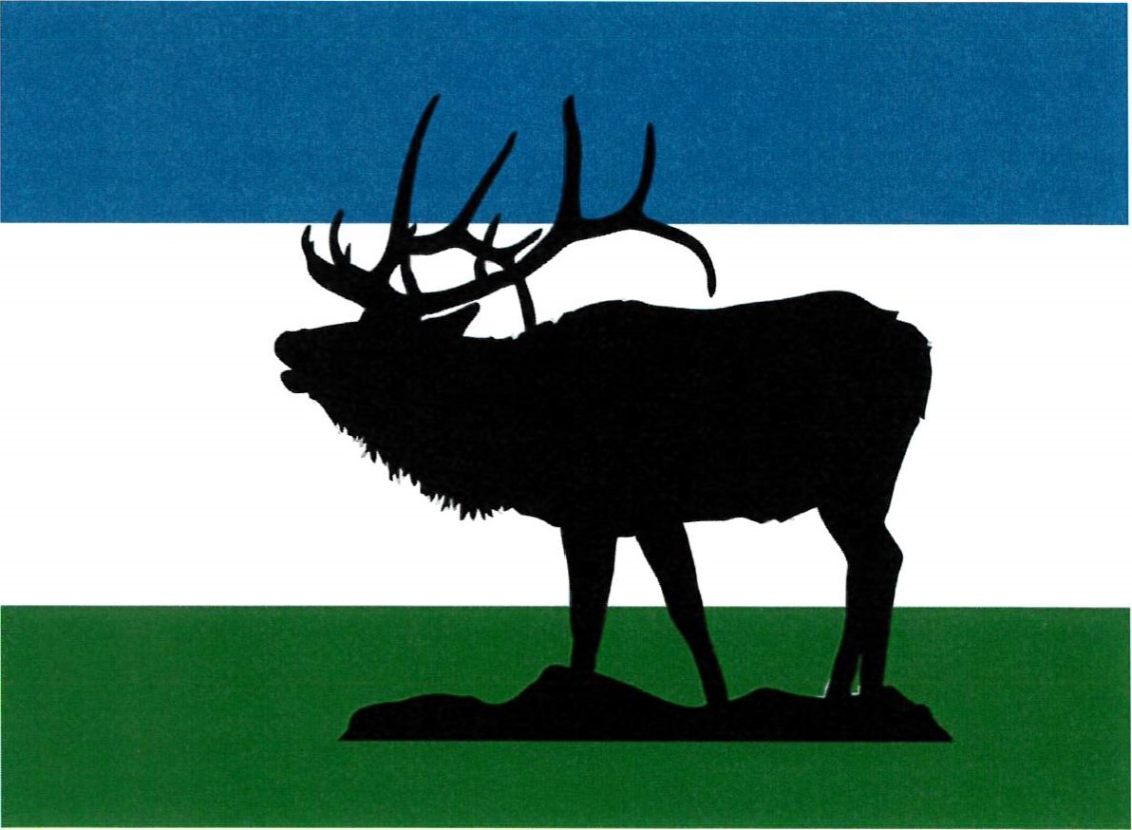

INTRODUCTION

WHAT IS THE GENERAL PLAN
The General Plan defines the overall vision of the city and is to be used as a guide for the decision-making process in order to achieve and maintain that vision. It should remain flexible enough to allow administrative and legislative processes to freely function, yet it must contain sufficient clarity and specificity to provide a framework for decisions.
City administrators must carefully consider the General Plan when implementing policies and ordinances set forth by the legislative body of the city. Likewise, the legislative body must carefully consider the General Plan when enacting ordinances or resolutions that affect the character of the city.
The General Plan also gives guidance to the residents of the city as they have considerable influence in how well the city conforms to the Plan. Residents should be able to easily read and comprehend the objectives contained herein.

COMPILATION AND APPROVAL OF THE PLAN
The General Plan is compiled jointly by the Planning Commission, City Council, city administrators and staff with input from residents of the city who wish to express their opinion. Once the compilation is complete it is adopted, by resolution, by the city legislative body with or without modification.

LEGISLATIVE AUTHORITY
The City of Elk Ridge in accordance with, Title 10 Utah Municipal Code, Chapter 9a Municipal Land Use Development and Management, Part 4 General Plan, of the Utah Code Annotated, has legally prepared and adopted the following general plan for Elk Ridge.

OVERVIEW

COMMUNITY VISION STATEMENT (INSERT PICTURES)
We desire to establish a safe, friendly, and family oriented bedroom community that coexists with the natural hillside environment where residents can enjoy the picturesque mountains, fresh air, native wildlife, and the grandeur of dark skies. This vision includes well-planned roads, parks, trails, and natural open space areas throughout the city with connection to nearby natural areas in cooperation with adjacent communities.

HISTORICAL SETTING
In 1968, a land developer named James Winterton purchased a portion of the 1,726 acre Goosenest Ranch from the James Fayette Shuler family. Mr. Winterton submitted a subdivision plat to Utah County under the project name of Salem Hills because of the close proximity of the development to the town of Salem. In the fall of 1971 the county approved the development, but as a condition of approval required the area to incorporate if the population ever exceeded 100 permanent residents. Over time residential lots were developed. On December 22, 1976, Salem Hills was incorporated. About a year and a half later, in a special election, the residents of the town voted to change the name to Elk Ridge. This appropriate name was chosen because of the elk herds that historically wintered in the vicinity of the town.
By 1980, there were 99 homes built in the town and the population had grown to 381 people. In 1990, the census reported that there were 771 residents living in 167 homes. The growth rate between 1980 and 1990 was a robust 102.36 percent. The 2000 Census stated the population was 1,838 residents with more than 300 homes, far exceeding any past projections. In the year 2001, the town of Elk Ridge officially became a city. From 2000 to 2010 the nation has seen a roller coaster of economic highs and lows ending in an economic recession with financial impacts not seen since the Great Depression of the 1930's. Utah's population continued to grow mainly due to births during this "lost decade" and Elk Ridge expanded at a modest pace to 2,436 residents and 584 homes. Since 2010 growth has accelerated, with the current January 2018 population reaching approximately 4,000 residents and 1,004 homes. According to the most recent (2020) census, Elk Ridge now has a population of 4,687 with 1,183 homes.
In August 2018, the massive Bald Mountain fire impacted everyone in our community by forcing all residents to evacuate for ten days. No homes/structures were burned, but this raised greater awareness of the need for vigilant fire safety practices/policies. In September 2018, unprecedented torrential rain caused flooding and debris flows in Loafer Canyon. By using sandbags and other emergency measures, there was minimal damage to homes and property but this highlighted the need for adequate permanent drainage/flood control measures for vulnerable areas in our city. Consequences of the worldwide COVID19 pandemic included a shift toward more people working from home and families spending more time in our community.
The history of the residents of Elk Ridge has always been that of a people whose priority is to live in a place where clean air, open space, and quiet and peaceful surroundings has been important. It is a place nestled at the base of Mount Loafer with a panoramic view found nowhere else in Utah County.

PLAN ELEMENTS
There are several elements covered in the General Plan. Each section describes the purpose for the element(as needed), element objectives, background information (as needed), specific considerations (as needed) and implementation (Call to Action) strategies. These are to help provide a blueprint for the planning commission, city council, city administrators, and citizens to carry out the intent of the General Plan. The elements found in this plan are: Land Use; Annexation; Economics; Transportation; Trails, Bikes and Pedestrian Facilities; Parks, Recreation and Open Space; Moderate Income Housing; and Demographics. Publicly provided services and associated facilities are covered in the city's Capital Facilities Plan.
LAND USE ELEMENT
PURPOSE
The Land Use element is the primary element to make the community vision a reality. The distribution, density, usage, and preservation of real property throughout the city will ultimately determine the overall character of the city. Special care should be used to assure all land use decisions are made in concert with this portion of the plan and the community vision.
A community is made up of people who differ in how they desire to use their residential property. The community also includes parks, churches, schools, and businesses, etc., which enhances the quality of life for all residents. City zoning should clearly define the parameters of land use within each zone, thus preserving the desirable characteristics of the community.

Zoning provides guidance for density of development, the size, height and location of structures allowed on a parcel. Zoning helps to shape the character of the community and protects the features of the natural surroundings, which are often the main reasons residents choose to live in Elk Ridge.

OBJECTIVE
Give guidance concerning the zoning, development, and permitted uses of land within the city.

BACKGROUND
Elk Ridge consists of approximately 1,820 acres or 2.84 square miles of land within its current city boundary. The annexation planning boundary for Elk Ridge potentially adds an additional 164 acres for a total build-out potential of 3.10 square miles.
Currently 1,091 acres or 60% of the total city acreage is developed or under development with approved lots. A little over 440 undeveloped acres resides in the CE-3 and HR-I Zones south of the currently developed neighborhoods. The remaining 270 acres are mainly located on the fringes of the existing development with some smaller areas interspersed throughout town. This translates the possibility of anywhere between 600 to nearly 1,000 potential new dwellings with a population reaching approximately 8,000 people. Growth over the last three years has been unprecedented with 9% in 2015, 12% in 2016 and almost 8% in 2017. With the continued growth residents have noticed a significant change in the community. To some residents the community may seem more suburban as formerly open ground is transformed into neighborhoods. While the pace of growth may slow down, it will continue to transform the character of the community. It is the role of zoning to help preserve the key characteristics that make Elk Ridge special in balance with personal property rights.

ELK RIDGE RESIDENTIAL ZONES
(INSERT PICTURES OF EACH ZONE)
RESIDENTIAL AND LIVESTOCK (CITY CODE: Title 10, chapter 8B, sections 1-9)
R&L-1-20,000 This zone allows for limited animal rights (number and animal types). Consideration must be given to the proximity of animals to neighboring dwellings.

CRITICAL ENVIRONMENTAL (CE-2) (CITY CODE: Title 10, chapter 9B, sections 1-10)

The CE-2 zone imposes on environmentally sensitive areas. These areas typically include, but are not limited to, areas with steep slopes, unique soils, drainages, and other natural conditions In order to preserve the natural look of the hillside the city encourages minimal disturbance on each building lot, but requires at least a 30-foot clear area around homes and other structures to create a defensible space for fire protection.
This zone does allow for grazing animals and other animal rights on large parcels. Consideration should be given to the types and number of animals to minimize impact on native vegetation and wildlife habitat and activity. It is also important that these lands are not fenced on steep slopes and through other natural features to allow unhindered wildlife activity and movement in the natural open spaces.

CRITICAL ENVIRONMENTAL (CE-3) (CITY CODE: Title 10, chapter 9C, sections 1-18)
This zone has been created in recognition that there are environmentally sensitive areas located on these parcels that need additional consideration as they are developed. The environmentally sensitive areas typically include, but are not limited to, areas with steep slopes, unique soils, drainages, and other natural conditions. It is also recognized that there is a large portion of the land in which slopes are conducive to development (20% or less slope). Like the CE-2 zone this zone allows for grazing animals and other animal rights on undeveloped privately owned large parcels. In order to preserve the natural look of the hillside the city encourages minimal disturbance on each building lot but requires at least a 30-foot clear area around homes and other structures to create a defensible space for fire protection.
To minimize development impact and maximize use of land, clustered home sites are recommended. The desired outcome of clustering is to locate homes in areas containing slopes of less than 20% that would provide buildable sites for multiple homes leaving remaining undeveloped acreage as natural open space or community park areas. The density of a site is constrained by the available buildable areas.

HILLSIDE RESIDENTIAL (HR-I) (CITY CODE: Title 10, chapter 8B, sections 1-9 and title 10, chapter 11C, sections 1-8)
The HR-I zone identifies areas that require special building consideration due to significant slopes. Extensive analysis of current environmental conditions must be completed to better preserve our natural resources. With any development, it must be demonstrated that environmental constraints are identified and preserved or mitigated. Open space on steeper slopes is a requirement. Strict requirements for cuts and fills, lot and road slopes, and encroachment on ravines, drainages, and ridgelines are used to preserve the uniqueness of the area. Grazing and animal rights must be in harmony with the usable lot areas within this zone.

RESIDENTIAL (R-1-20,000) (CITY CODE: Title 10, chapter 7B, sections 1-9)
The R-1-20,000 zone allows for subdivisions of one-half acre or larger lots. Uses include single-family dwellings, home occupations, and accessory apartments. Animal rights are limited to types of animals that are appropriate for a residential neighborhood.
RESIDENTIAL (R-1-15,000) (City Code: Title 10, chapter 7A, sections 1-9)
The R-1-15,000 zone allows for smaller lots in a more compact setting. Uses include single-family dwellings, home occupations, and accessory apartments. Animal rights are limited to types of animals that are appropriate for a residential neighborhood.

RESIDENTIAL (R-1-12,000) (City Code: Title 10, chapter 7C, sections 1-9)
The R-1-12,000 zone historically allowed for small lots of one-fourth acre in size typically used for single-family dwellings and accessory apartments. The zoning is now limited in its use to provide for the ability to develop the Bella Vista neighborhood which includes parcels that do not meet the R-1-15,000 minimum square footage but do match the square footages of the surrounding lots in the Salem Hills Subdivision. Other use of this zoning designation is only applicable to areas within the city already designated as such. Those areas include the Elk Ridge Meadows PUD and the Horizon View Farms PUD. No additional areas shall be zoned R-1-12,000 including new annexation areas.

COMMERCIAL ZONING

GENERAL COMMERCIAL (City Code: Title 10, chapter 10A, sections 1-9)

This zone is for appropriate retail and service facilities designed to satisfy the needs of Elk Ridge and the surrounding areas. It provides for a variety of goods and services to the people who visit, live, and work in Elk Ridge. These facilities should be in appropriate locations where a combination of business, entertainment, and related activities may be established, maintained, and protected. Commercial uses adjacent to residential areas must be designed to ensure privacy, tranquility, dark skies, and limited access to residential property. Adequate buffer or transition areas should be in place between commercial and residential areas. Traffic patterns pertaining to commercial facilities should have no material impact on residential traffic of the surrounding local streets. Commercial activities within an Urban Wildland Interface Zone must be designed to mitigate potential wildfire threat to the fullest extent possible.
PUBLIC FACILITIES ZONING

PUBLIC FACILITIES (PF) (City Code: Title 10, chapter 11A, sections 1-6)

This zone is where public and quasi-public uses are placed throughout the community. Uses in this zone include, but are not limited to, uses such as city buildings, major utilities, parks, open spaces, golf courses, churches, libraries and cemeteries.
Public facilities should be designed to protect the tranquility and privacy of surrounding residential areas. Traffic patterns pertaining to public facilities should have no material impact on residential traffic of the surrounding local streets.

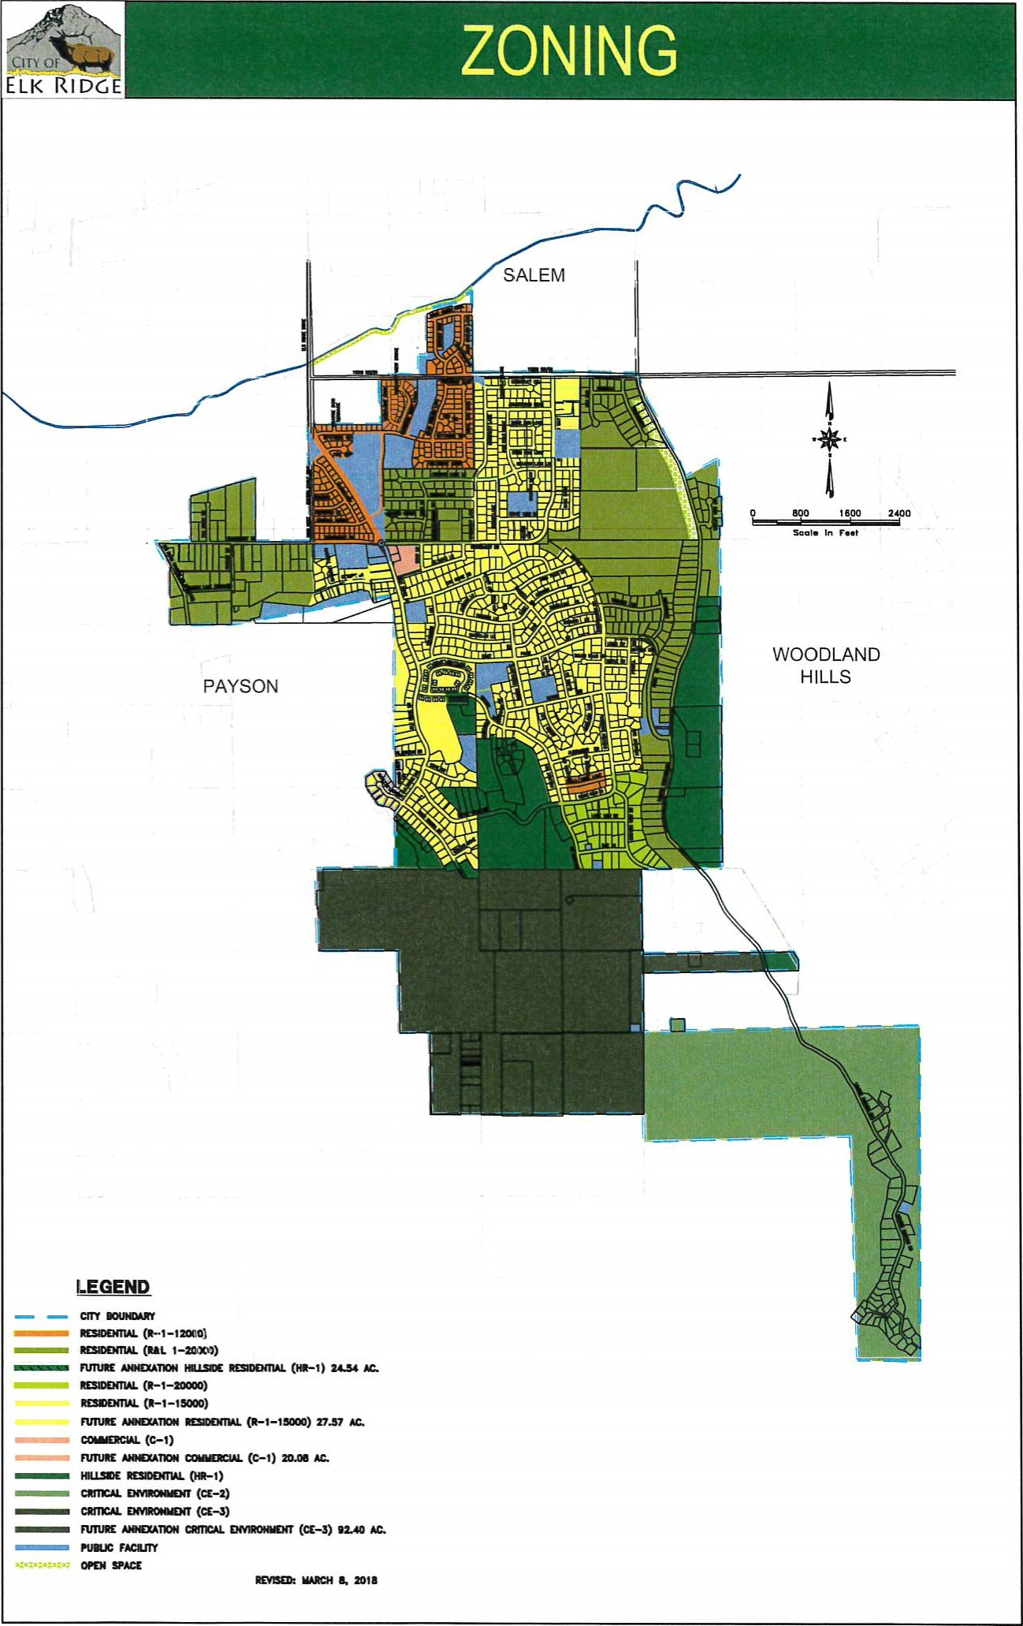
ZONING POLICY CONSIDERATIONS

COMPLEMENTARY LAND USES

Planned land uses should complement adjacent development types and local environmental conditions.
Removal of natural landscape features including but not limited to ridgelines, ravines, and mountain tops shall not be permitted. Removal of such features would be a gross violation of the city's desire to be complimentary to the existing landscape.

ENVIRONMENTAL HAZARD

Planned development on or along steep hillsides, ridgelines, ravines, drainages, and other natural features within any zone should be carefully studied and analyzed for geological destabilization and watershed impact. Any findings that indicate development would materially increase existing hazards or would introduce new environmental hazards should not be allowed.

SERVICE AVAILABILITY

Services applicable to, and appropriately engineered for, any given zone (sewer, water, storm drainage, roads, etc.) must be constructed prior to, or as part of, any new development.
Emergency equipment access within a zone must be a primary concern to the leaders of the city. There should be no plans for development within a zone without ordinances that clearly enumerate conditions upon which any given zone can be developed within.

DUE PROCESS

All development projects, whether for commercial, public, or residential, must follow the appropriate process as described in the Elk Ridge Development Code or where not specifically defined as required by state code. Private and public developments shall be required to follow the same processes.

Sensitive Areas Map

Final City Council Approval = 23 sept 2008 Map Produced by Mountainland GIS Department Map
Production Date: January 2010
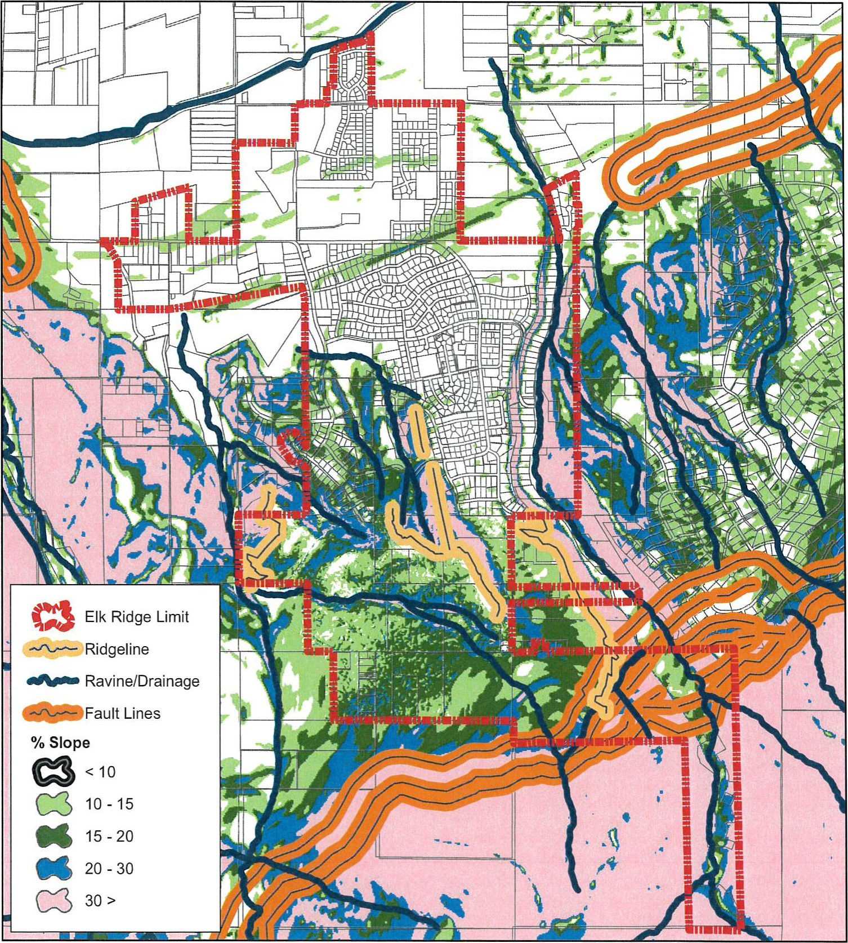
This map is for reference only.
Development setbacks from sensitive areas shall be delineated when required detailed work is done at the development stage. All Ravines/Drainage, Fault Lines, Ridgelines and 30% slopes shall also be considered Wildlife Corridors.
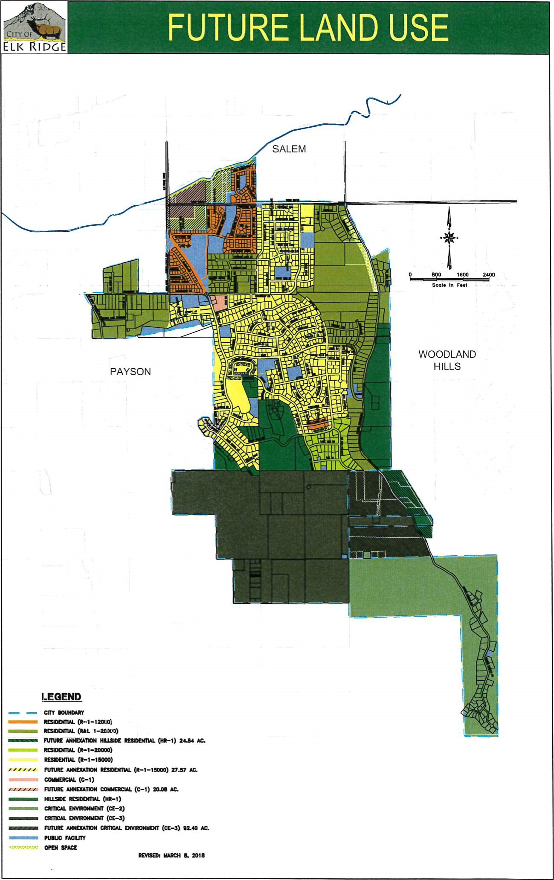

CALL TO ACTION

ADJUST ANIMAL RIGHTS ORDINANCE The animal rights ordinance(s) must be reviewed annually to ensure it addresses any limitations according to zoning plans.

REVIEW ZONING ORDINANCES
Ensure every zone has applicable ordinances that specifically deal with the following:
- Emergency equipment access.
- Water, sewer, and storm drain services.
- Multiple ingress and egress requirements in case of wild land fires, earthquakes, or other natural events.
- Protection of significant natural landscape features
- Introducing or increasing the likelihood of an environmental hazard.

UPDATE ZONING MAPS
Review, and update if needed, all zoning and land use maps annually. A biannual review of the General Plan is required. Anytime an annexation occurs, or zoning changes, the land use and transportation elements are reviewed to make sure that the impacts to the plan are understood and addressed. Impacts to the Capital Facilities Plan should also be considered.

STORM DRAINAGE PLAN DOES THIS BELONG HERE?
A plan to have curb and gutter uniformly installed throughout the city should be created. This plan should include a timeline based on residential density with the high-density areas addressed first. The use of Special Improvement Districts (SIDS) is a viable option for funding as is the securing of grants.

CREATE LAND USE PAMPHLET FOR RESIDENTS MODIFY OR DELETE

The natural surroundings of Elk Ridge and its mountainside location are unique and essential to the identity of the community and its vision for the future. These same characteristics however create potential hazards that can be damaging. Citizens, land owners, and community officials should work together to identify and avoid inappropriate land uses and activities in the various zones. In order to help educate the residents of the city about our unique land use vision and on how to protect our natural surroundings a pamphlet should be created and made available to every household.

EDUCATE RESIDENTS ABOUT THE WILDLAND URBAN INTERFACE MODIFY

Elk Ridge is designated as a wildland urban interface area. This means that the city recognizes the unique hazards that are created by choosing to live on a mountain side surrounded by minimally developed natural habitat. There are inherent dangers with respect to fire because of the community's location. Residents need to be aware of these dangers and informed of steps they can take to protect not only themselves but also their neighbors. A "Fire Wise" pamphlet should be provided to all residents. Opportunities should be taken to remind residents of fire wise practices in monthly newsletters and by providing opportunities for seminars or booths at local events. The city may also provide opportunities to help with fuel load reduction through removal and chipping events. Grants are available for these types of activities and will be beneficial for providing educational opportunities.

ANNEXATION ELEMENT

ELEMENT PURPOSE
Utah state law requires every community to have an Annexation Policy Plan. Upon adoption of the General Plan, this Annexation element shall act as Elk Ridge's Annexation Policy Plan.

BACKGROUND
Elk Ridge is a small community with approximately 4,000 residents as of January 2018. Elk Ridge is located at the base of Mount Loafer and adjacent to the cities of Payson, Salem, and Woodland Hills. It is a bedroom community and the existing area within the city will remain that way. A small portion of the city is zoned commercial primarily for assisted living facilities. Any additional commercial development will require annexation of additional land at the north boundary of the city within the existing inter-local annexation area.
Proposed annexations should be a minimum of 5 acres in size, contiguous to the city, and within the annexation policy growth boundary area. Smaller annexation areas will be considered if they eliminate islands.
ANNEXATION ELEMENT OBJECTIVES

MUNICIPAL SERVICES

Elk Ridge has capacity in both its culinary water and sanitary sewer systems for future growth within its current corporate boundaries. As new annexations are processed, the city will review each application for its impact on municipal services. The applicant of each proposal will need to mitigate any negative impacts on the city services and facilities. Because the city has minimal income from commercial activities, bonding for service improvements and expansion should be a last resort.

IMPACT FEES

As annexation occurs it is imperative that the impact of additional development on the existing infrastructure be considered and that Impact Fees are appropriately adjusted to account for any upgrades to existing infrastructure that are required to maintain existing levels of service.

POTENTIAL TAX CONSEQUENCES TO RESIDENTS

Existing residents should realize the potential tax consequences due to annexation and the resulting development activities. Commercial annexation should be done with plans to reduce the existing tax burden or increase desired services. Residents within the existing annexation area should be notified of the potential taxation impact prior to or at the time of any initial public hearing concerning the annexation.

INTERESTS OF ALL AFFECTED ENTITIES

There are five possible affected entities for annexations surrounding Elk Ridge. The affected entities are Utah County; the cities of Payson, Salem, and Woodland Hills; and the Nebo School District. These entities may submit comments at the public hearing or up to 10 days following the public hearing related to any annexation activities.

UPDATING THE GENERAL PLAN

Any annexation activity is in reality an update to the General Plan. The public hearing for annexation must include the proposed update to the General Plan so as to incorporate all zoning and expected land-use elements of the annexation area.

ANNEXATION AND BOUNDARY CHANGES

In addition to the basic zoning definitions listed previously, the zoning of additional areas due to the annexation of unincorporated land or due to a boundary change between cities must consider the following:
- Potential impact of mixing land uses between commercial and residential zones that share a common boundary. Priority should be given to the protection of the tranquility, privacy, dark skies of and access to, residential areas and property.
- Traffic patterns generated from commercial zoning should limit the impact on local roads in any material way. This includes, but is not limited to, the amount of traffic, the types of vehicles, the time of travel, and the noise emitted from vehicles.
- Potential impact of mixing land uses between zones that grant more permissive animal rights with those more restrictive in their animal rights. Ordinances should protect the property owner in zones with the most restrictive animal rights from exposure to the unintended consequences of neighboring zones.
CALL TO ACTION UPDATE

PREPARE FOR ANNEXATION

There are very few areas left for annexation into the City, but each area has a potential impact. The areas in Loafer Canyon would very likely be annexed because of a desire to develop the land. Infrastructure is not in place in the canyon for development. The City should be prepared with a plan for what infrastructure is needed for development in the south part of the canyon so that the improvements can be included in the annexation agreement. The land to the east of Elk Ridge Drive and adjacent to 11200 South would very likely develop as residential, but a portion could go commercial. The guidance offered in the commercial code should reflect the fact that the community is a bedroom community and commercial development should occur in a manner that complements the surrounding residential neighborhoods. Infrastructure will also be an important part of the development of this north area. A new pressure zone for water will need to be created. Entrance along 11200 South will need to be carefully considered as well as what impacts the development will have on the Elk Ridge Drive / 11200 South Intersection. In this case it also makes sense to consider these issues before an application is submitted so that the City is prepared and not scrambling to catch up with little to fall back on.
ANNEXATION MAP? – required as of 2021?

ECONOMICS ELEMENT
PURPOSE
Increased tax revenue through the development of commercial property can provide an additional revenue stream to the City to help offset the cost of providing some public services that citizens desire. However, it is not likely that significant commercial growth will accompany projected population growth such that we do not anticipate substantial increases in additional revenue from commercial activities. Never the less, it is important that the City be prepared to address economic opportunities that present themselves with a plan and ordinances that will guide economic growth in harmony with the community's character.

BACKGROUND
The city's biggest challenge for economic development is also its biggest asset for quality of life. That is, Elk Ridge's isolation. The city is located on the foothills of Loafer Mountain, without an existing regional transportation route through the city. Elk Ridge's population is relatively small with the majority of workers leaving the city to work in other communities. Many people live in Elk Ridge to get away from the "hustle and bustle" of more urbanized areas. Any economic development activity in Elk Ridge must be pursued with the knowledge that much of what makes Elk Ridge desirable from a residential stand point, also makes commercial development more difficult.
ELEMENT OBJECTIVE
The Economics Element outlines the activities and policies applicable to economic growth within the City.

ECONOMIC DEVELOPMENT POLICY CONSIDERATIONS

COMMERCIAL DISTRICT
Establishing a centrally located commercial district is not in harmony with the desires of the majority of the city's residents. Any commercial district should be located where the likelihood of success is greatest and has the least impact to residents. Annexation will likely be required to establish a proper commercial district.
Although many large cities have been successful with mixed use commercial projects, the size of any commercial district within Elk Ridge would not be suited for a mix of residential and commercial development wherein a "self-contained" community should be considered.
TYPES OF COMMERCIAL DEVELOPMENT

Commercial development should be in harmony with the city's fundamental nature of being a bedroom community. Retail sales, office space, and professional services shall be chosen that are harmonious with Elk Ridge. Some of the characteristics that must be considered include but are not limited to:
- Traffic patterns confined to collectors or arterials with no need for traffic to travel local residential streets. Businesses are closed during night time hours.
- Businesses, signage and parking areas comply with dark sky standards with no light pollution straying onto neighboring properties.
- Businesses provide adequate buffer between the business activities including parking from surrounding neighboring lots.
- Businesses do not emit noises, smells, and sights that are out of characteristic with a residential neighborhood.
- Any service or sales restricted to age groups of 18 years and older are not desirable in a small community like Elk Ridge where accesses to businesses of this type are available in nearby communities.

LOCATION OF COMMERCIAL DEVELOPMENT

The expectation for commercial development is to provide increased revenue to the city. The best source of revenue is retail sales which are difficult to generate in a remote location such as Elk Ridge. Any commercial development should be located where patronage can be maximized which is likely at the very north end of the city along 11200 South which is slated to become a major element of the south-valley corridor.
CALL TO ACTION

UPDATE COMMERCIAL ORDINANCES

With the eventual annexation of areas along 11200 South, it is likely that this will be the location for commercial development. Therefore, it is imperative that the city develop strong commercial ordinances before such annexation occurs. This should be an immediate call to action for city planners and leaders.

BE PREPARED FOR ANNEXATION REQUESTS

With the 2018 update to the General Plan portions of the north annexation area have been identified as potential commercial areas. Commercial development should front and access 11200 South. Side and rear boundaries of commercial properties that are adjacent to residential zones must include appropriate buffer areas that include a physical barrier such as a solid wall and landscaping with trees to soften the look of the transition. Other types of buffering may also be considered.
The County also has development restrictions in place on land surrounding active agricultural operations. These restrictions specifically affect land along the canal adjacent to the Allred's orchards. The County must be consulted, and restrictions taken into account before any proposal for annexation in the 11200 South / Elk Ridge Drive area is brought before the city for consideration. All mitigation requirements for a common boundary between residential and commercial should be addressed before the annexation request is made.

TRANSPORTATION ELEMENT

ELEMENT OBJECTIVE
The transportation element is designed to provide for the safe and efficient movement of people and goods in the city. Its primary purpose is to balance current and future demands generated by projected future growth with roadway improvements. In essence, it is a long-range transportation plan that would efficiently support future land development and ultimately the Elk Ridge vision.

BACKGROUND
Physical limitations of the mountains and being located at the southern end of the Wasatch Front will continue to keep Elk Ridge a bedroom community. Our transportation system, for the most part, acts like a cul-de-sac. The only opportunities for through movement will be at the far northern edge of the city or recreational trails to Payson Canyon.

ROADWAY CLASSIFICATION
Elk Ridge has five road classifications, each playing a part to move people and goods to and from homes and businesses within and outside the city. Road classifications within this plan represent a local definition and description and are not intended to reflect any county, state, or federal definitions. Rather they provide an effective method for designing a circulation system that fits the needs of the city.
Roadway Classification
 | ROW
Regional Arterial | 150 ft | Limited to major intersections
Arterial | 1 10 ft | Limited to road intersections
Collector | 66 ft | At intersections, can be driveway
Minor Collector | 56 ft | At intersections, can be driveway
Local | 56 ft | Driveway

REGIONAL ARTERIAL

The right of way for the corridor is quite large at 150 feet. Of this, only four travel lanes and shoulders are proposed, taking up less than half of the right of way. The remaining area will be in the wide median and side buffer areas that will include landscaping and a trail system.
The proposed South Corridor will traverse mostly along the current Utah County 11200 South. The corridor was recommended by Mountainland Association of Governments (MAG) as a future non-freeway belt route connecting the south Utah County municipalities to 1-15 in Payson and US-6 in Spanish Fork. The proposed Nebo Beltway Road will eventually connect to Utah County and Payson. Maintenance of, and speed limits on, regional arterials roads is the responsibility of Utah County.

ARTERIAL

Arterial corridors require 110 feet of right-of-way with the paved roadway area being 58 feet. This leaves 52 feet for a median, landscape buffer zones to the sides, and a trail system. These roads are limited access at other intersecting roads. No driveway access is allowed.
Elk Ridge Drive from the north city limit to the roundabout is the only Arterial corridor in the city. Speed limits should be set according to road design and existing roadway standards. All of Elk Ridge Drive should have the same speed limit with areas of lesser advisory speeds pertaining to roadway features and pedestrian crossings.
Off Highway Vehicles should not be allowed on Arterial corridors due to the expected traffic volume.
Arterial Road
Elk Ridge Drive | Goosenest North
UC 11200 South (Regional) | Entire Length
Goosenest | Elk Ridge Drive West
Canyon View Drive | NB from Park Drive to 11200 S.

COLLECTOR

Collector roads require 66 feet of right-of-way. These corridors carry traffic from the local neighborhoods to the arterials. These roads will have more traffic than a local road. Speeds should be set appropriately. Driveways can access these roads, but new subdivisions should be designed so driveways access local streets where applicable. Parcels with driveways accessing a collector street should be developed to allow vehicles to turn around internally on the parcel so vehicles may exit the parcel facing forward.
Collector roads with a speed limit of 30 MPH or less may also be appropriate for OHV traffic.
 | Collector Road
Goosenest Drive |  | Rocky Mountain Way North
Elk Ridge Drive |  | Goosenest South
Park Drive |  | Entire Length
Canyon View |  | Entire Length
Loafer Canyon |  | UC 11200 so to Park Drive
Salem Hills Drive |  | Elk Ridge Drive to Canyon View Drive

MINOR COLLECTOR
Minor Collector roads require 56 feet of right-of-way. These corridors carry traffic from the local neighborhoods to the arterials. These roads will have more traffic than a local road, but less than a collector. Speeds should be set appropriately. Driveways can access these roads, but new subdivisions should be designed so driveways access local streets where applicable. Parcels with driveways accessing a minor collector street should be developed to allow vehicles to turn around internally on the parcel so vehicles may exit the parcel facing forward.
Minor Collector | Limits
Hillside Drive | Elk Ridge Drive North to new South Mountain Road
Park Drive/Loafer Canyon Road | Canyon View Dr to Canyon View Dr (new road)
Ridge View Lane | Rocky Mountain Way to Canyon View Drive

LOCAL

Streets that are not otherwise classified are Local streets. These are the neighborhood streets that handle local traffic.
Local streets should have a speed limit not to exceed 25 MPH and OHV traffic is appropriate on these streets.

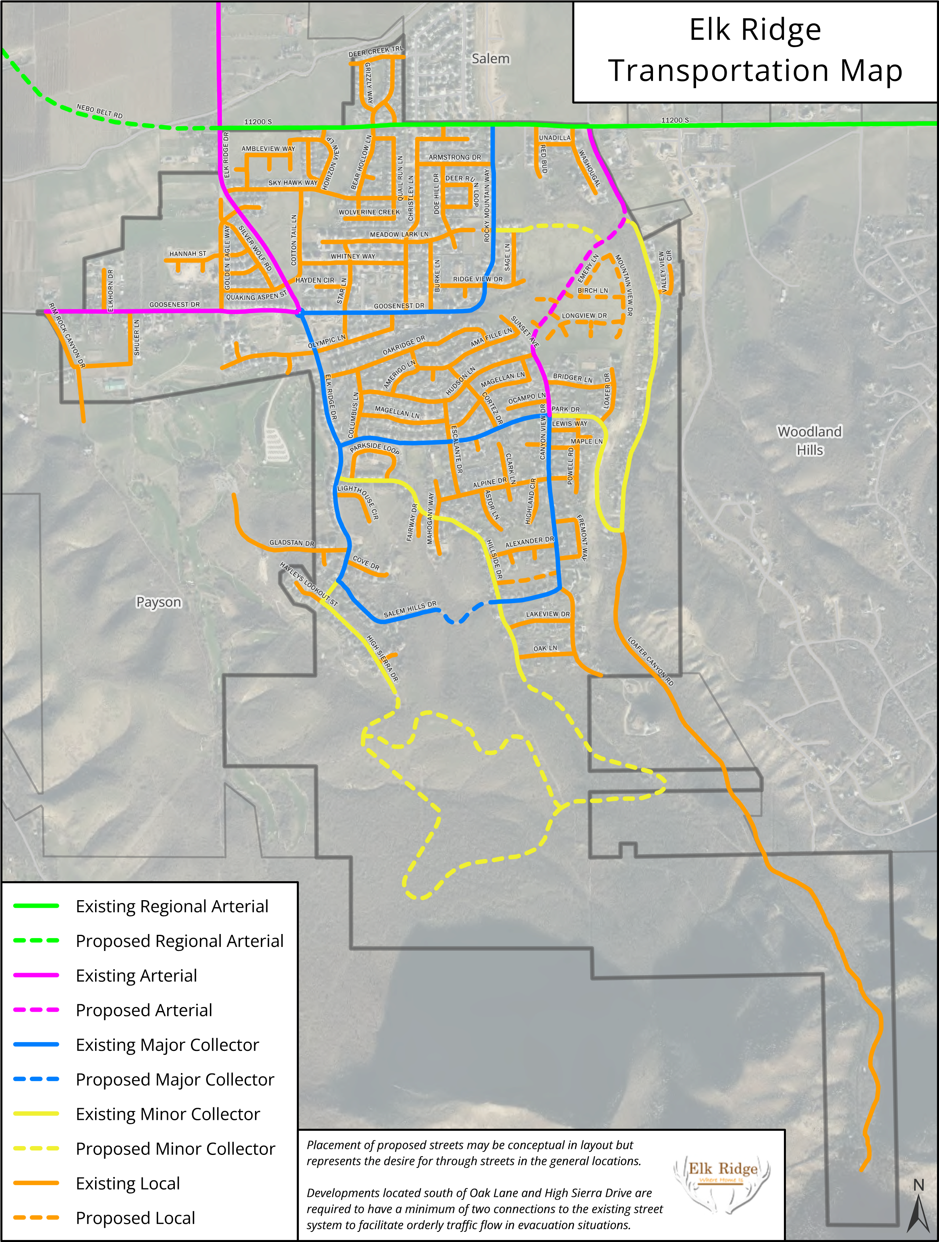

TRANSPORTATION POLICY CONSIDERATIONS

NEW ROADWAYS

As new roadways are planned and developed within the city, they must be reviewed for compatibility with neighborhoods, footprint sensibility within hillside and sensitive environmental areas, and safety. In addition, all new roads must adhere to requirements found in the city codes, standards, and the official Master Transportation Map. Subdivisions must have collector road access for local street access.
As the street system is further developed it is critical that the realities of living on a mountainside are taken into account. Grades effect the ability for emergency equipment, school busses, garbage trucks, moving trucks and snow plows to efficiently access the neighborhoods. Grades must be minimized where possible. Neighborhoods need multiple access points onto the city street system to provide alternatives during winter weather and the ability to efficiently evacuate neighborhoods in an emergency situation such as a gas leak or threat of wildfire.
In order to maintain effective evacuation procedures and limit congestion in neighborhoods, cul-de-sacs and temporary dead-end streets must be limited in length as well as the number of dwellings served by the street. A maximum of 16 single family dwellings or 24 multifamily dwellings should be allowed on a single access street. Lengths should not exceed 500 feet from the access point with the nearest through street. However, due to the larger lot sizes associated with some zones a maximum of 800 feet of length may be approved for no more than 16 single family dwellings where no reasonable alternative exists to provide a second access. A second access shall be provided with the extension of a street beyond the dwelling and length limits. It is important that temporary dead-end streets allow for the provision of a permanent cul-de-sac if extension of the street to gain a second access becomes infeasible. Extension of temporary single access streets shall be shown in the preliminary phasing plan with a Development Agreement providing for a defining "temporary" with respect to timing of the extension and providing a provision to create a permanent cul-de-sac if the extension becomes infeasible in the allotted time. These measures are critical to allow the City to provide for snow removal and emergency services in a safe and effective manner.
CALL TO ACTION

ROADWAY MAINTENANCE PLAN

With 19+ miles of roads and counting, it has become critical that we create a roadway maintenance plan that can be used to schedule all aspects of roadway maintenance including but not limited to replacement, rebuild, resurface, and sealing. This plan needs to be the main consideration as city leaders budget for such work throughout the years ahead.
ROADWAY SAFETY IMPROVEMENT PLAN

Identify and prioritize the roads within the city that need special attention to improve their safety. This includes, but is not limited to, roads that force vehicles to slope out of a curve (instead of into the curve), roads with significant environmental hazards, blind hillsides and curves.
Mitigation of such roadway could include additional signage, redesign, closure, privatization, etc.

ROADWAY DEVELOPMENT CONSISTENT WITH PERMITTED LAND USE

Review all zoning and development codes to ensure roadway design takes into consideration the slope, environmental impact, cutting, grading, plowing, and storm water runoff as indicated in the land use element of this plan. Preliminary design reviews with the developer must include discussions on each of these items as defined in city code and this plan.

PEDESTRIAN, BIKE AND TRAIL FACILITIES ELEMENT

ELEMENT OBJECTIVE
Pedestrian, bike, and trail facilities are an integral part of the vision for Elk Ridge. This element provides direction to city planners regarding facilities that support and encourage safe, interconnecting, non-motorized travel throughout the city, gaining mountain access, and connection to adjacent community trail systems.

BACKGROUND
Elk Ridge did not construct sidewalks and did not envision the need for a trail system in its early days. There have been great strides forward with a variety of appropriate pathways (sidewalks and trails) in support of non-motorized travel throughout the city. In the early days, access to the mountains/wilderness areas seemed to be available to the general public. People simply were not aware nor respectful of private property ownership. Access to the mountains and wilderness area on the south end of the city is currently restricted.

TRAIL CLASSIFICATION

SHARED ROADWAY

Shared roadway trails consist of a designated pathway running adjacent to motorize travel lanes of streets without a physical separation between the two. These pathways are prominently identified by signage and markings within the path to indicate the intended purpose. Motorized travel or parking of any kind is not permitted within a shared roadway trail. Restrictions include but are not limited to: ATVs, golf carts, and motor scooters, etc. Equestrian use is not permitted on pathways adjacent to collector and arterial roadways.
This is the least desirable of all trail implementation due to the proximity to motorized traffic and therefore should be considered as a last resort and is most applicable within older areas of the city that have no planned trail system.
Shared roadway trails must be designed for both pedestrian and bicycle traffic.

SIDEWALK

New developments are required to have sidewalks as part of the subdivision plan. Sidewalks that serve both pedestrian traffic and bicycle traffic must be designed with sufficient width to safely allow for both uses. Sidewalks from each neighborhood should be tied to a dedicated pathway that will access the trail system. This section of sidewalk connecting neighborhoods to trails should safely accommodate pedestrian and other non-motorized users. Sidewalks within a subdivision that are alongside streets of local designation should be designed mainly for use by pedestrians although limited use by bicycles is allowed. Prohibited use of sidewalks include but are not limited to: ATVs, golf carts, motorized scooters, and equestrian.

DEDICATED PATHWAY

A dedicated pathway within the trail system is the most desirable of all trail types. These paths are typically not located on or directly adjacent to vehicle travel lanes or paved shoulders. They are separated by a buffer or located in a dedicated right-of-way separate from the street system. Dedicated pathways minimize conflicts between nonmotorized users and automobiles and give the user a sense of calmness while on the trail. Dedicated pathways are for any non-motorized form of travel and must be designed as such. Dedicated pathways should follow the contour of the existing landscape and must not disturb the natural surroundings beyond the pathway itself. These may be paved or, in an appropriate environment, be left as a natural, unpaved trail. Some dedicated pathways are appropriate for equestrian use, but signage must be used to warn pedestrians of this condition
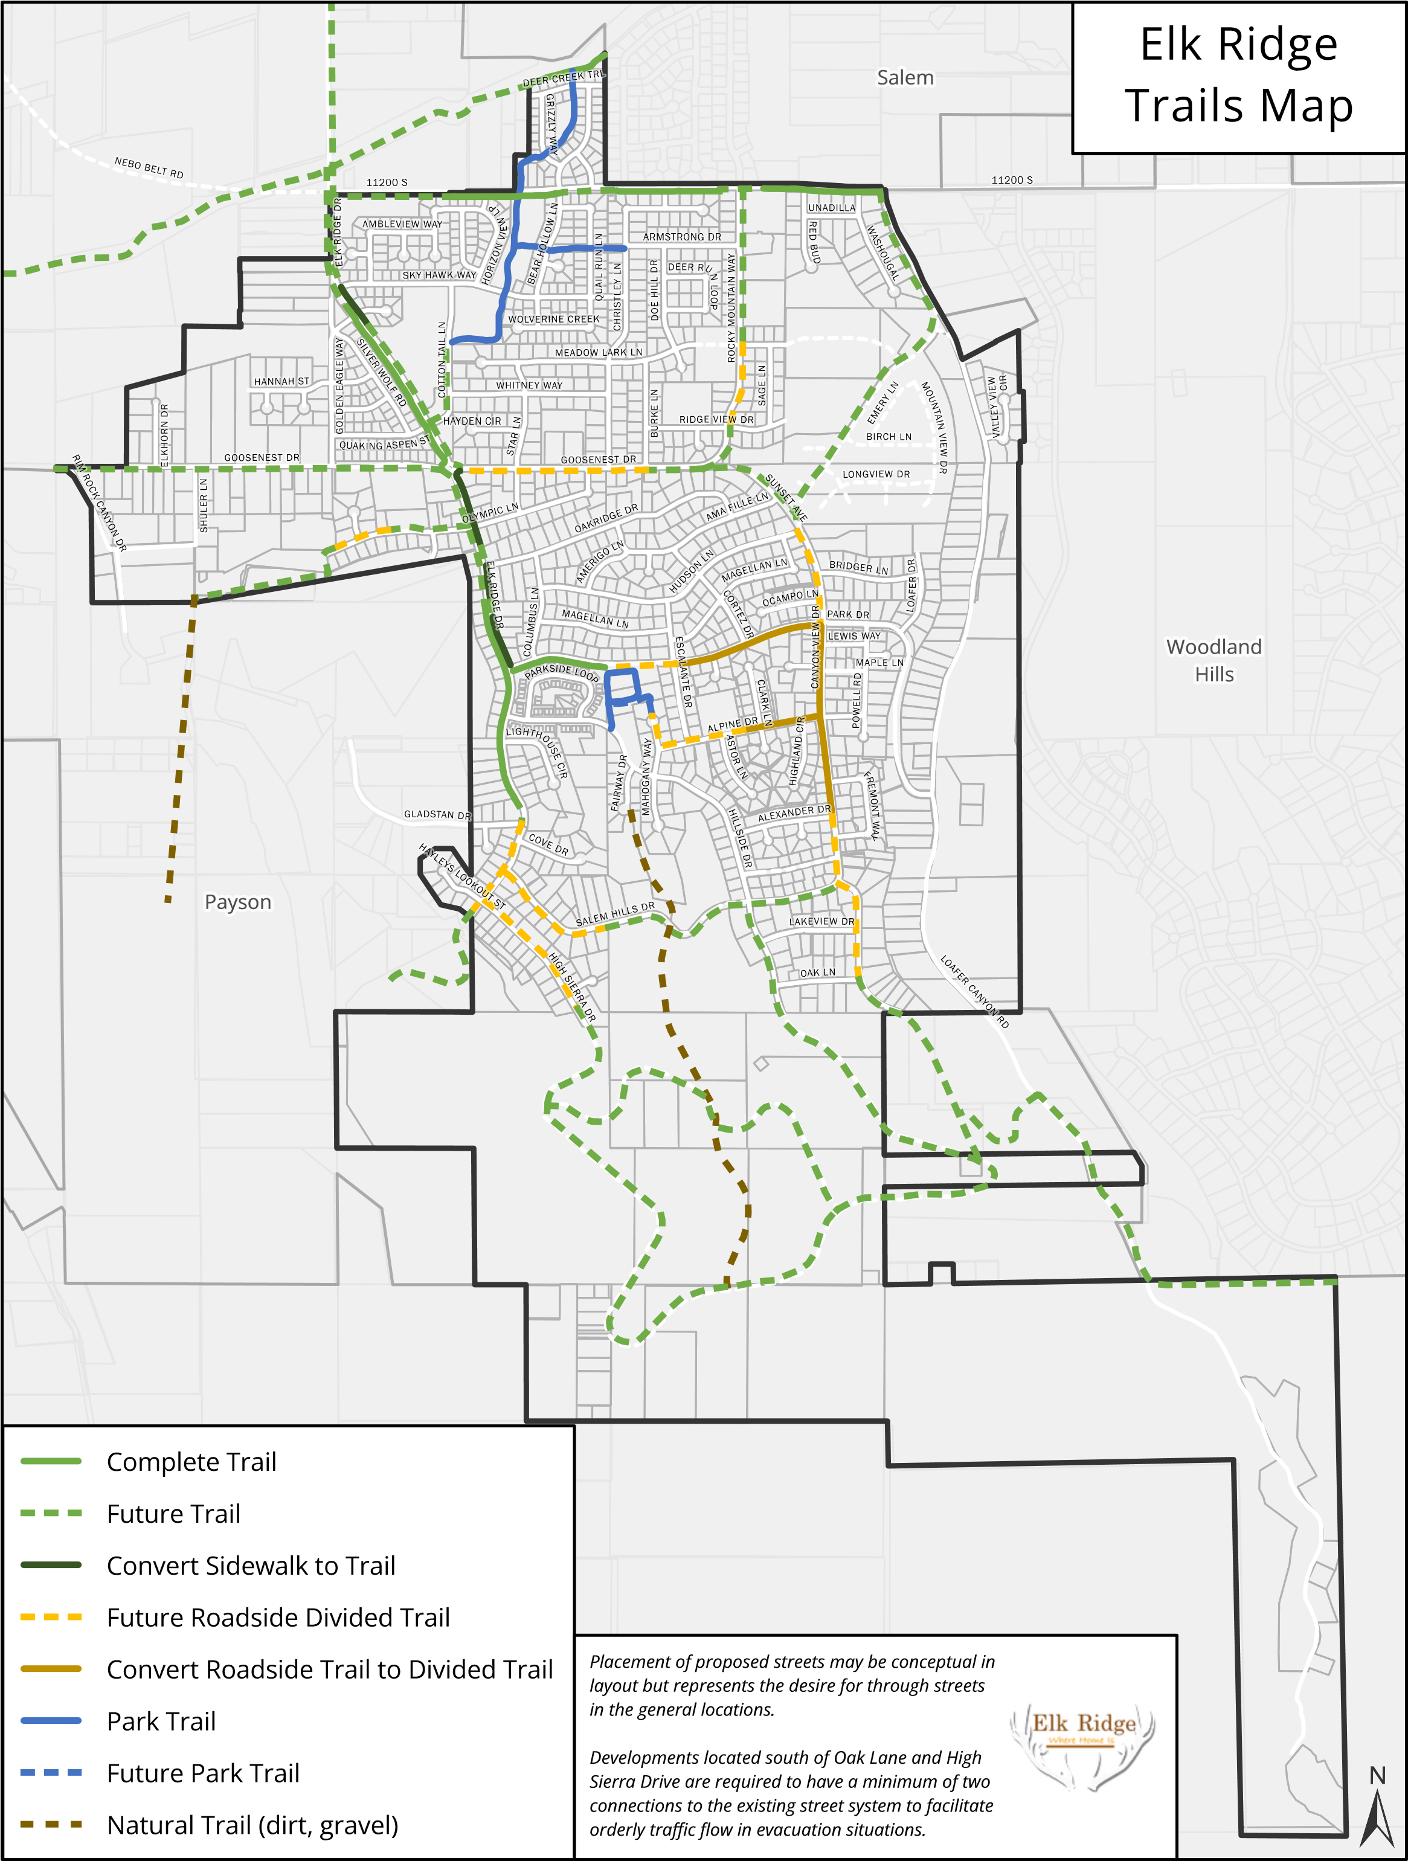
TRAIL POLICY CONSIDERATIONS

SAFETY

Trail planning should consider the safety of those using the trails above all other aspects of its design. Designing trails such that there is physical separation between motorized and non-motorized travel is highly desirable.
Mixed types of non-motorized travel should be considered during the earliest planning stages. Pedestrian, bicycle, and equestrian uses are vastly different and may not be applicable in all parts of the trail system.
Signage of various types should be used to inform potential trail users of the type of use the trail is intended for.
When a trail is required to cross over an area such as drainage, or crosses a street, there must be a specific safety element included in the design of the trail at that point.

CONNECTIVITY

Connectivity is a key to any viable trail system. The overall trail plan is one that connects residents to all public and commercial facilities with exclusive use of the trail system. Sidewalks are an important part of the trail system connectivity and an emphasis should be placed on establishing sidewalks within subdivisions that can easily accommodate them. The plan will include a trails system that connects to our neighboring communities and the regional trail system to allow pedestrians and non-motorized vehicles to have an extensive, clear, and safe route to traverse the beautiful mountains, foothills, and canyons of Utah valley. It is imperative that the city work with private property owners to gain access for trails to the mountains and connect with adjacent community trails systems.

MAINTENANCE

Maintenance must be a consideration during the design of the trail system. Although access to the trail system is limited to non-motorized traffic, motorized maintenance equipment must have access to any area of the trail.
LAW ENFORCEMENT AND EMERGENCY ACCESS

Dedicated pathways within the trail system must be designed to allow law enforcement and emergency vehicle access. Although parts of the pathways may be impassible by such equipment, there must be access points at appropriate locations.

CALL TO ACTION

Create a well-connected network of parks and trails that serves all Elk Ridge community members.

Identify areas where sidewalks and trails need to be designed, modified, or created to establish connectivity throughout the city.

Consider land ownership, appropriate pathway (sidewalk or trail) as per trails map and master plan.

The Master Plan should include: prioritizing projects, a timeframe for completion, cost, and avenues for funding.

Adhere to Elk Ridge Trails Map
- The 2023 update to the General Plan includes a map that details the existing and proposed trail system. The map includes areas in which existing development will require a paved trail.
- The trails map is designed to provide access to the trail system from all neighborhoods and connect to major points in town as well as regional connections.
- As new development occurs developers are required to install trails according to the trails plan and are required to provide connections to the trails system from each neighborhood.

Actively Fund Trails
- The City must continue to actively seek for funding to connect existing trail sections within city boundaries and creating new trails that connect to adjacent community trail systems by applying for regional, state, and federal grants. First consideration should be connecting to the mountains beyond our city limits.
Citizen support for the proposed trails is high. As seen on the accompanying chart, citizens were most supportive of a trail to Forebay. Yet, they also prioritized trails throughout the city and trails connecting to neighboring city trails. The city should follow this prioritization order, if possible, to support citizen needs.

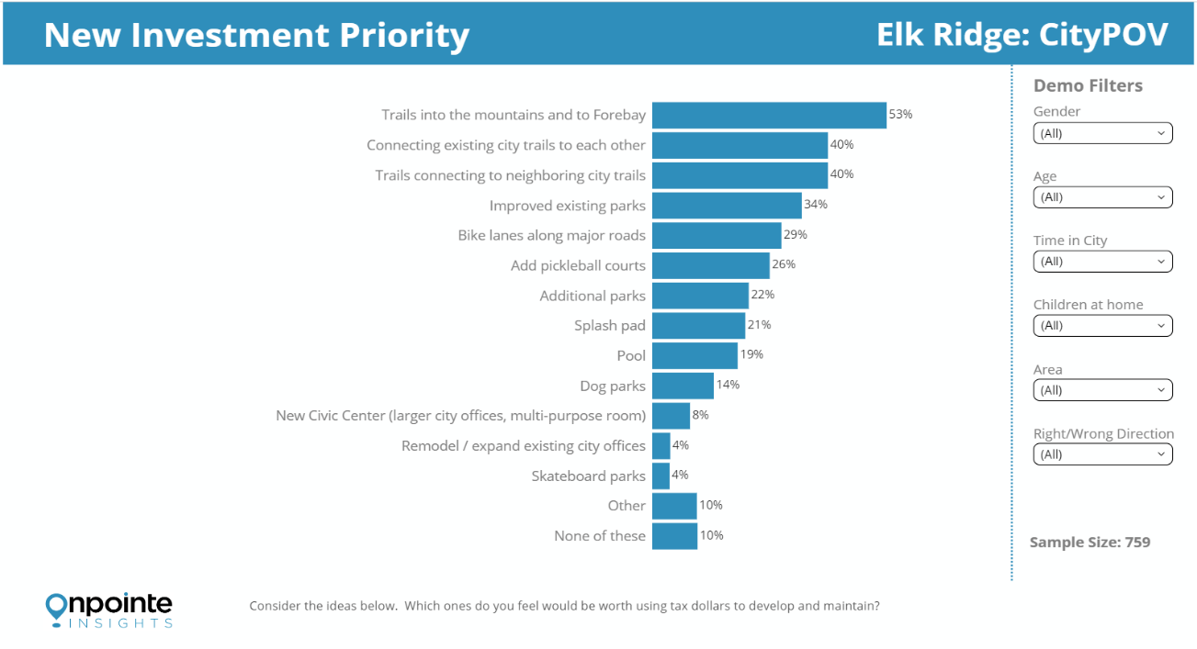

PARKS, RECREATION, AND OPEN SPACE ELEMENT
ELEMENT OBJECTIVE
Park space, recreational opportunities, and open space is a fundamental part of every good community. This element will help guide city planners as they balance the need for parks, recreation, and open space with the cost of maintaining and operating such areas and related equipment.

BACKGROUND
Elk Ridge is home to a relatively young, active population. However, citizens of all ages and abilities need park space that is accessible, well maintained, and contains amenities that make the park pleasant and useful. Following the suggested guidelines of the National Parks and Recreation Association (NRPA), the city has set the standard of a minimum of 5 acres of park space per 1,000 residents. In 2008, the city had just over 7 acres of park space. The standard suggested that we lacked 5 acres. Over the past few years significant park and open space has been added which now totals over 13 additional acres of park space. However, much of that park space has limited use at this time due to the lack of amenities. If the projected population of almost 8,000 residents is reached at build-out, the required park space will be at least 40 acres.

A 2022 citizen survey found that the community values trails that connect with other cities, as well as trails that provide access to the mountains. Understanding this the city has recognized that the traditional definition of a park is only one component in a successful park system. Park space could also include natural open space with trails for a variety of users, quiet picnic or day camp areas and community wide accessibility.
Parks must provide a variety of components for the residents to enjoy. Whenever a park component or recreation opportunity is considered, city planners and leaders must address the components usability, sustainability, maintenance costs, and safety, as outlined in the Capital Facilities Plan.

OPEN “NATURAL” SPACE
Open space is a critical component of a comprehensive, well-balanced parks and recreation system. Both private and public open space provide a host of ecological and ecosystem benefits, such as sites for purification of the soil, water and air; places where the impacts of noise, wind and visual disturbances can be buffered and absorbed; and places where native vegetation and natural wildlife can prosper. In other words, a robust open space system helps create a healthier community.

As development occurs, the city will work with land owners to conserve these valuable spaces while creating beautiful, well-planned places to live, work, and play. The overriding, guiding consideration should be on preserving and enhancing the natural resources and environment whenever possible and carefully integrating man's works with nature. Prime areas for Open Space preservation can be identified by referencing the Sensitive Areas map and focusing on natural areas that cannot be developed due to: steep slopes, ridgelines, ravines/drainage areas, wildlife habitat areas and corridors, watershed and well protection areas. Public parks and open space, whether public or private, need to be considered separate components in this element of the General Plan.

RECREATION
A good park design allows for recreation and enjoyment of all people regardless of age and abilities. Park amenities such as baseball or soccer fields, basketball or multi-use sport courts, pickleball courts, splashpads and children’s play equipment are all components to consider. Public health and a sense of community are enhanced by recreation programming. Organized sporting programs for our youth such as soccer, baseball, and/or basketball are desirable but require specific park design features and dedicated adult support. Community interest, input, organization, and planning are major components in creating a successful sports program.

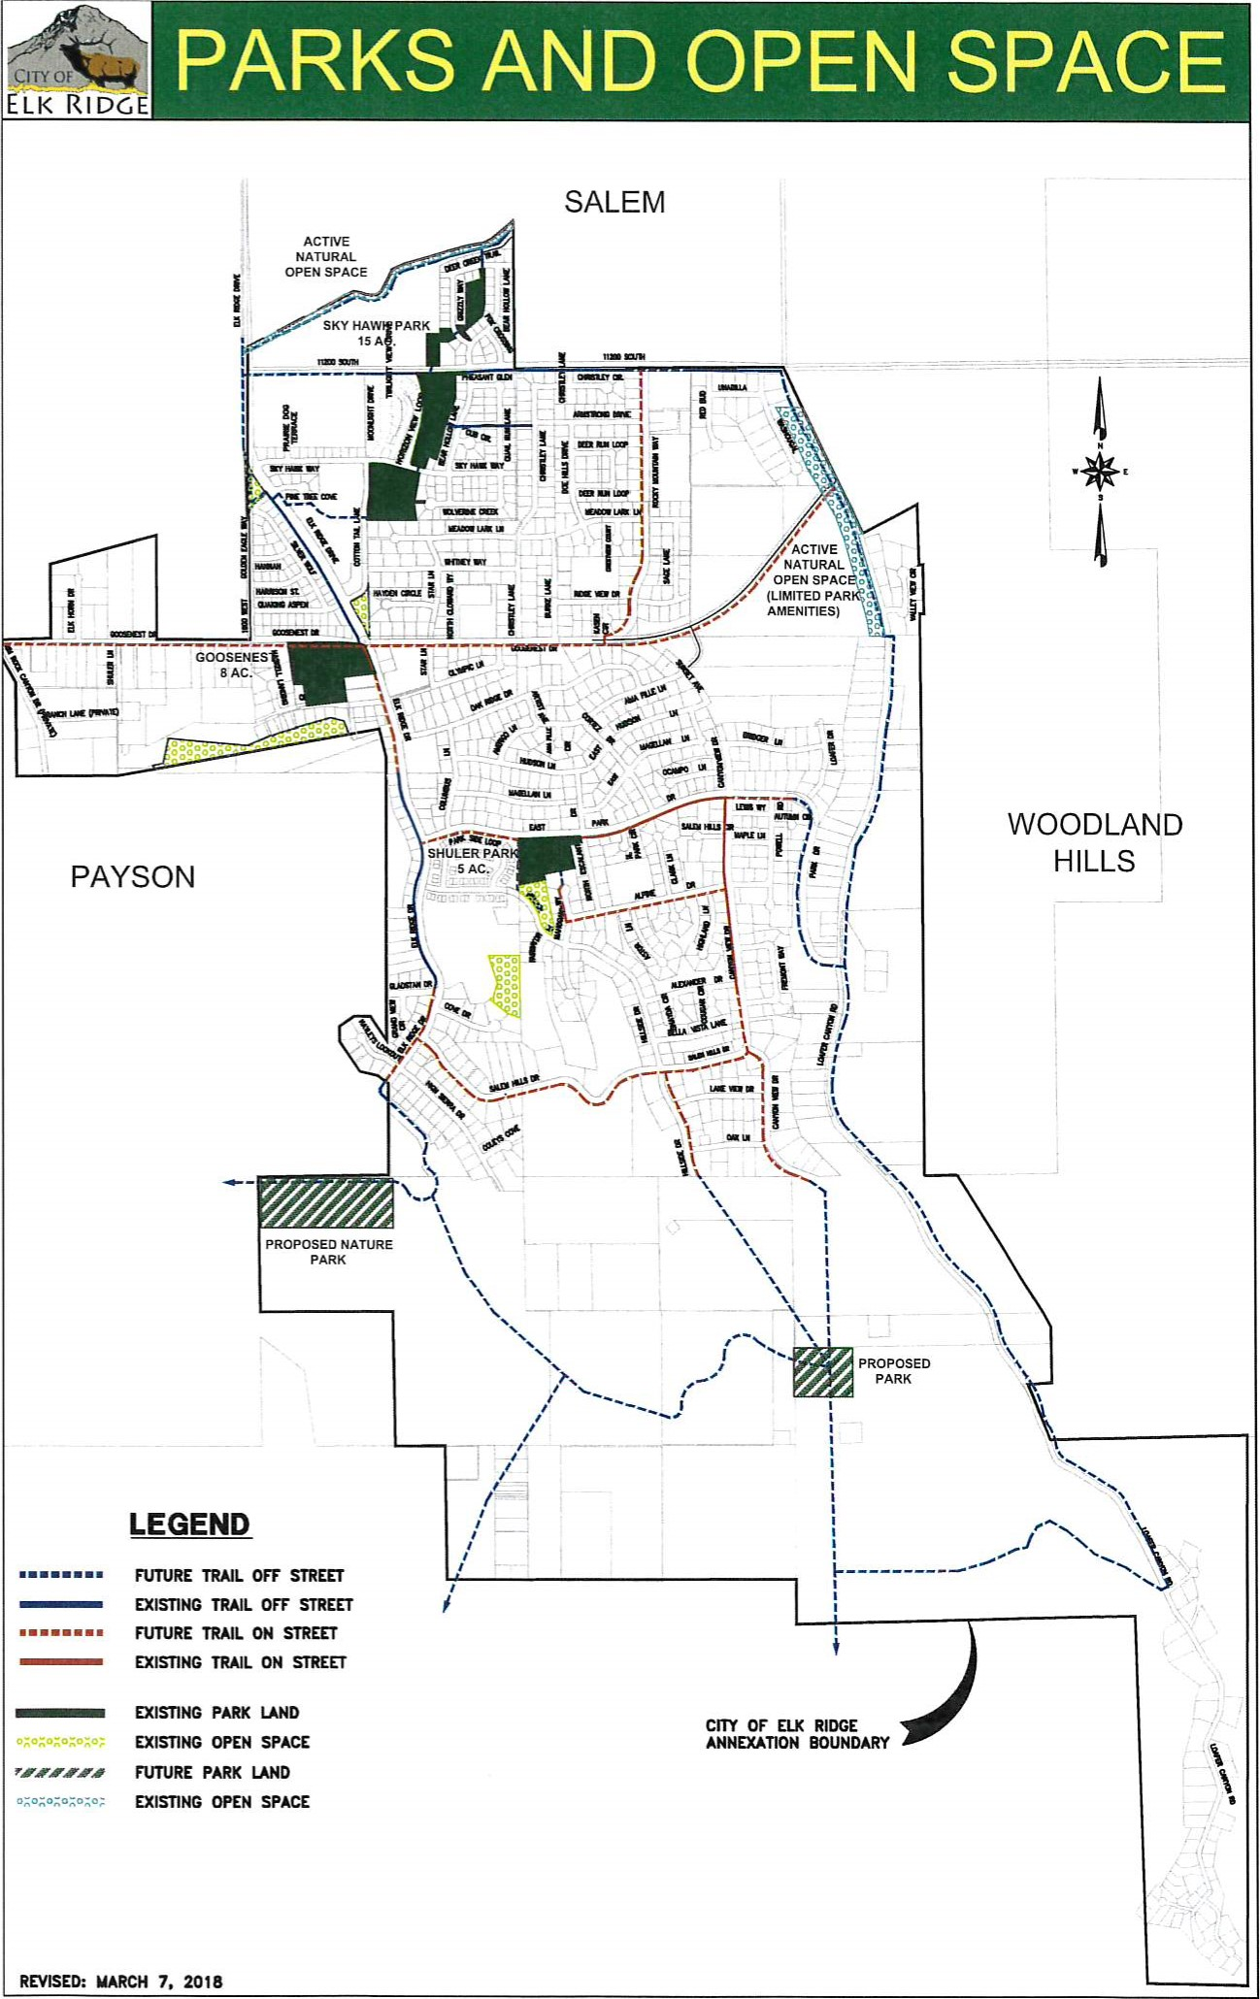
PARKS AND OPEN SPACE POLICY CONSIDERATIONS

SUSTAINABILITY

There must be a balance between the type of park components and the cost to the city to maintain such areas. Soccer fields and the associate large grassy areas are needed within the city. These areas are also aesthetically pleasing and offer a multitude of uses for residents. However, great consideration must be given to the sustainability of such areas due to the significant quantities of water required to maintain a healthy lawn.
City planners must reduce the demand for water throughout the city and parks are the number one consumer of water.

PRESERVATION

Parks and natural open space serve to help preserve the natural characteristics of the community and its surroundings. Preservation of these characteristics must be taken into consideration as development activity occurs and plans and ordinances should be amended to identify these characteristics and promote their preservation.

USABILITY

Parks must be well maintained and provide amenities that residents will use. Open space may also be utilized by the community as a source of recreation and solace when trails are provided in open space areas. Each park and active open space area should be evaluated to determine its intended purpose and the amenities that will be provided prior to acquisition and development. The evaluation should take into consideration the location and accessibility of the site, the types of amenities desired by the community and the appropriateness of the site to host those amenities.

ACCESS

Parks and active use open space should be easily accessible to all residents of the community. The areas should be located throughout the community with trails connecting into surrounding neighborhoods allowing residents to use non-motorized means of travel to conveniently access the parks and active open space.
Parks that include high use amenities such as fields for organized sports, a splash pad, access to the mountains, or utilized for community events need to contain adequate onsite parking to allow those traveling from other areas in town or from other communities to access the amenities.

SAFETY

As parks are designed and developed the safety for its users should be first and foremost in consideration of each element. Park spaces should be visually open and easily accessible to law and emergency services. Park facilities should be frequently inspected for damage and improper function on a schedule appropriate for the amenity and well maintained. Vandalism should be quickly addressed, and video surveillance is recommended.

VARIATION

Parks and open space will vary in uses and size. In the interest of providing amenities desired by the residents and remaining fiscally responsible each proposed park should be designed with specific types of use in mind based upon the need for those uses. Some uses may apply to all parks, such as children's play grounds and pavilions, but every park does not need a multi-purpose field or tennis courts. By providing a variety of uses each park will be unique and will provide for the varying interests of the residents.

DEVELOPMENT

The Parks and Open Space Map details the locations of existing parks and general locations of desired future parks. Each park should be described in the City's Capital Facilities Plan so that as development occurs the parks may be incorporated into the development. The City and Developer should work in partnership to provide parkland that will benefit the residents and enhance the desirability of the surrounding development. The City should use park impact fees to encourage dedication and development of parkland and active open space areas.
CALL TO ACTION
- Ensure that Elk Ridge City’s current and future residents are well-served by a comprehensive system of parks, recreation facilities, and open space.
- Create a master plan. This plan will include a vision and plan for each park or open space area within the current and future city boundaries. It will include citizen input, goals and priorities for development, plans for amenities, access and parking and plans for funding and maintenance. The plan will use the Capital Facilities plan as a base.
- Improve water efficiency by utilizing Smart and WaterWise irrigation systems.
- Future parks should be developed with water conservation in mind, sizing grass areas based upon the minimum needed for specific amenities and allowing additional acreage to be left in its natural state with trails for active use, or other uses.
- Identify areas suitable for future parks as the city expands geographically.
- Obtain and provide adequate funding for park maintenance, park construction, recreation programs, and adequate maintenance staff.
- Pursue a diverse array of funding sources, such as grants, bonds, and public-private partnerships. Conservation Easement funds? National source
- Pursue appropriate impact fee assessments to support new growth and development
- Provide ongoing opportunities for community engagement.
- Offer Park improvement and maintenance volunteer opportunities.
- Use community engagement to identify opportunities for new programming that aligns with needs and trends (soccer teams, pickleball play)
- Allow community members to comment on the design/amenities of proposed new parks/recreation facilities (parks committee, recreation committee, beautification committee)
- Create a web page with park descriptions and maps that highlight current and future park improvement.

Update Capital Facilities Plan and Park Impact Fees
Each existing and proposed park should be described in detail in the Capital Facilities Plan with estimated costs for development. Those costs should then be used to determine how the improvements will be paid for and what portion is attributed to new development and thus eligible to be included in the impact fees. It is very important that the Capital Facilities Plan and Impact Fee Analysis be reviewed and updated on a regular basis and especially any time new annexations, or rezoning occur that may affect the need and timing of new improvements and may require adjustments in the impact fee amount.
Have we completed these two sections?

ENHANCE ZONING LAWS TO PROTECT OPEN SPACE

The Development code should be updated to reflect the desire to preserve and protect open space. Development restrictions currently found in the CE-2, CE-3, and HR-I zones concerning slope protection, minimizing cut and fill requirements, preservation of ridgelines, natural drainages, and other natural features should be relocated into the general requirements of the development code and applied to similar physical features located in any zone.

OPEN SPACE NETWORK MAP

Connectivity of open space is beneficial not only for wildlife but also to help retain the character of living in a hybrid natural setting. The visual effect of contiguous natural open space provides the feel that the community is nestled in a larger natural space. As open space is preserved the Parks and Open Space map should be updated so that the City can work with surrounding developers to preserve contiguous tracts of open space.

MODERATE INCOME HOUSING
(Amendment Adopted August 26, 2014)
Note: (The City is working with a real estate professional to get the local market data required by the state to generate the calculations of need for housing in each designated income category. This section will be updated after this data is received and the state model has been run.)
INTENT OF MODERATE HOUSING ELEMENT
Utah law (10-9a-103-36) requires that municipalities, through the general plan process, plan for moderate income housing, addressing the following five issues:
I. An estimate of the existing supply of moderate income housing located within the city.
- An estimate of the need for moderate income housing in the municipality for the next five years as revised biannually.
- A survey of total residential land use.
- An evaluation of how existing land uses, and zones affect opportunities for moderate income housing.
- A description of the city's program to encourage an adequate supply of moderate income housing.
MODERATE INCOME HOUSING DEFINED
Moderate income housing is defined as (Utah Annotated Code 10-9a-103-29) 'i. .housing occupied or reserved for occupancy by households with a gross household income equal to or less than 80% of the median gross income for households of the same size in the county in which the city is located." The 2014 Area Median Income AMI, as provided by HUD office of Community Development (CPD), for Utah County is $64,200. Elk Ridge's median household income level as provided by CPD is 21%
higher than the county level at $80,871
In order to place the definition of the State Code in real terms, it is helpful to understand that affordable housing is generally deemed to be "Affordable" if the cost of monthly housing expenses is of gross household income.
The following table defines the income levels, lists affordable monthly housing expenses for each income level, and maximum mortgage amount at each income level based upon the 2014 AMI. Maximum Mortgage Amount calculated on 30-year loan, 4.25% interest rate, mortgage insurance 0.6%.
 |  |  | 2014 Affordable Housing Calculation
Income Categories Area Median Income (AMI)* |  |  | Yearly Income |  | Monthly Income for Housing Expenses |  | Maximum Mortgage Amount
0% AMI |  |  | $19,260 |  | $481.50 |  | $15,039.00
 | to AMI | > $19,260 to $32,100 |  | $802.50 |  | $74,270.00
 | to AMI | > $32,100 to $51,360 |  | $1,284.00 |  | $163,118.00
 | to '100% AMI | > $51,360 to $64,200 |  | $1,605.00 |  | $222,349.00
MODERATE INCOME HOUSING SUPPLY
The currently available housing quantities are derived from a review of the market on July 14, 2014 including existing homes for sale, homes available through the Self-Help Homes program, 74 recently approved townhomes, and available lots. The inventory is split into the income level categories based upon comparison of property cost vs. Maximum Mortgage Amounts.
Available Units by Income  Level | For Sale | For Rent | Combined  Total
'30% AMI |  |  | 0
to AMI | 13 |  | 13
to S80% AMI | 50 |  | 50
to SIOO% AMI | 42 | 1 | 43
AMI | 160 |  | 160
5 YEAR MODERATE INCOME HOUSING NEED
The projected five-year housing demand has been calculated using the Utah Affordable Housing Forecast Tool
UAHFT 1.3 developed by the Utah Division of Housing and Community Development. The model uses the population projections by the Governor's Office of Planning and Budget, 2010 Census Data, the American
Community Survey 2007-2011 (ACS) economic data, Housing and Income data provided by the Department of Housing and Urban Development Office of Community Planning and Development (CDP), and the available housing inventory. The Total Units are derived using growth in households based upon population growth, converted to housing units
accounting for vacancy's (7.8%)and total occupied housing (584 units) from the 2010 Census Data. The Units by Income Level are derived from the CDP Area Moderate Income Categories and CDP local housing information for each income category. The model projects that data forward by decade from the 2010 base data. The 2010 — 2020 data has been split using the population growth percentages and spread through each year. Each number corresponds to the projected number of new units required for each income level each year.
 |  | Projected New Unit Demand 2014 to 2020
Units by Income Level |  |  | 2014 | 2015 | 2016 | 2017 | 2018 | 2019 | 2020
Total Units |  |  | 691 | 721 | 752 | 784 | 818 | 853 | 890
s-30% AMI |  |  | 1 | 1 | 1 | 1 | 1 | 1 | 1
to | AMI |  | 2 | 2 | 2 | 2 | 2 | 2 | 2
to | AMI |  | 3 | 3 | 3 | 3 | 3 | 3 | 4
to | AMI |  | 5 | 5 | 5 | 5 | 5 | 6 | 6
100% AMI |  |  | 18 | 19 | 20 | 21 | 22 | 23 | 4

SURVEY OF RESIDENTIAL ZONING
The City has nine zoning classifications which allow for residential uses. Due to the unique and environmentally fragile setting in which Elk Ridge is located, most of these zones maintain a single-family character. The Commercial and Senior Housing Overlay do allow for multi-family environments and other creative housing options. All the residential zones allow for accessory apartments. The Land Use Element of this plan describes the various land use designations and the development capacity available within the various land use designations.

EVALUATION OF ZONING'S EFFECT ON HOUSING OPPORTUNITIES
The Elk Ridge planning commission and city council hold one of the many keys to providing housing opportunities for moderate income households. The key the city holds is zoning. However, the city's situational setting lessens zoning's effect on housing prices. The community leaders are constrained in their ability to modify zoning by the limited availability of developable land within or around the city. Market conditions and supply and demand may have significant impacts on affordability. Elk Ridge is located on the alluvial fan of Loafer Mountain, and many properties within the city are covered with scrub oak and varied terrain. Land in the area is desirable and, in a free market society, commands a high price. Due to slopes and other environmental factors, some housing costs are higher in Elk Ridge. The increased construction costs are a major factor affecting affordability. Some of these constraints are life safety issues beyond the control of city officials. Some issues are associated with the wild land/urban interface which is unique to Elk Ridge.
Experience has shown that adjustments in density that would be compatible with the city's infrastructure, and topography would have a limited effect in reducing the total cost of housing. Smaller 7,000 square foot lots that should have met the need for moderate income housing, especially after the 2008 financial crisis bankrupted the project and significantly reduced land costs, have been purchased by those in a higher income bracket who have filled each lot with large homes and minimal yards. The Self-Help housing program purchased some of the developed lots at the bankruptcy sale which and was successful in constructing moderate income homes through subsidy. A 72-unit multifamily housing project approved by the City was scrapped as the builders found the costs to construct on the hillside outweighed the market value. The city has provided the opportunities for moderate income housing, but the market does not support it. The final sales price does not necessarily reduce in direct proportion to a reduction in lot size.
PROGRAM TO ENCOURAGE MODERATE INCOME HOUSING
Elk Ridge currently allows for a mix of residential densities, including accessory apartments, throughout the community. The Senior Housing Overlay Zone also allows for multiple units. Current zoning allows the opportunity for affordable housing. The city will continue to support a variety of housing types to provide homeowners multiple options. With a supportive regulatory environment, the market drives the types of housing options available. It must also be noted that households making 30% or less of the AMI will more than likely need government rental assistance in addition to any zoning assistance from the city.

SPECIAL NEEDS
Elk Ridge has a growing number of elderly citizens that desire to stay in the community. Some are finding as they age, their current homes in which they raised their families no longer met their needs. Some desire smaller homes, with little to no yard work, possibly single level living or facilities that provide various social activities or various levels of assistance. The Senior Housing Overlay Zone allows for this type of development. Elk Ridge will benefit from continued support of new housing options for the elderly and also for those with disabilities by retaining language within the code supporting these types of uses.
POLICY CONSIDERATIONS

CONTINUE TO ALLOW ZONING THAT ENCOURAGES A MIX OF QUALITY HOUSING TYPES FOR ELK RIDGE

It is recognized that the community's location on the mountain side heavily influences the costs for development which in turn drives market pricing and housing types. However, Elk Ridge can continue to provide zoning and development ordinances that encourage a mix of housing types such as allowing accessory apartments, and senior housing options along with a mix of lot sizes.
CALL TO ACTION

MONITOR PROGRESS

Regularly update the Moderate-Income Housing element and Affordable Housing Model to determine the housing needs for all groups, to quantify specific housing needs, and to identify solutions to housing problems.
LOOK FOR MODERATE INCOME HOUSING OPPORTUNITIES THROUGH PARTNERSHIP

Continue to work with programs such as Self-Help Homes, where these programs provide opportunities that fit within the fabric of the community.

DEMOGRAPHICS – update after Capital Facilities is updated – November?
INTRODUCTION
A demographic analysis of Elk Ridge City's current population, land-use, development patterns and development potential has been completed based upon the vison set forth in this General Plan. The results of the analysis have been used as a basis for projection of future growth and its distribution throughout the planning area. For purposes of the General Plan these projections help to understand the potential impacts to land use if the vision of the General Plan is implemented. These projections will also be used as one of the factors to estimate future service demands and capital projects required for the community.
POPULATION
Like much of Utah, Elk Ridge experienced significant growth up until 2008 when the national economy and real estate markets plummeted. Growth and development slid from over 5% per year to nearly 0% during the economic downturn. Over the last several years (2010 to 2017) growth has accelerated from 3 to 4% a year in 2010 to 2013 to a high of 12% in 2016. In 2017 the pace of growth decreased to 7.7% over the year.
Elk Ridge City estimates its current (January 2018) population to be approximately 4,000. Currently there are 1,089 existing residential lots and 1,004 dwellings. Building permits for new homes in 2017 reached 95. The inventory of available building lots has dropped significantly from over 300 lots in 2013 to 85 in January 2018. The land available for development within the Elk Ridge annexation boundary that does not contain steep slopes or is in close proximity to existing infrastructure consists of approximately 44 acres along 11200 South, 38 acres in the west Goosenest area, 96 acres in the north-east quadrant bounded by Canyon View Drive, Rocky Mountain Way, and Loafer Canyon Road, 13 acres middle town Elk Ridge Drive, 7 acres in Salem Hills Subdivision, and possibly 40 acres in the south end of town, totaling approximately 238 acres.
The City estimates that the near-term growth rate will continue to slide over the next two years at roughly 6% in 2018 and 5% in 2019 as no new subdivisions have been presented to the City in the past year and remaining phases of existing subdivisions are almost complete. Based upon the projected slide in development, by mid-2019 the current inventory of available building lots will have been eliminated with a lesser number of new lots made available as a result of new development. From 2020 to 2024 growth is projected to remain at 3.5% reducing the more affordably developed land by approximately 100 acres. Because of the limited land availability, growth from 2025 through build out will likely occur at a rate closer to an average of 2.0% per year.
These projected growth rates are shown in Table 1.

Table 1: Projected Growth Rates
 | Year |  | Growth Rate
 | 2018 |  | 6.0%
 | 2019 |  | 5.0%
 | 2020 to 2023 |  | 3.5% for 4 years
2024 plus |  | Maintain 2.0% until build-out
Figure I. plots the projected population over the 20-year planning period.

Figure 1: Population Projection

Elk Ridge Population Projection
1970 1980 1990 2000 2010 2020 2030 2040 2050 2060
10,000
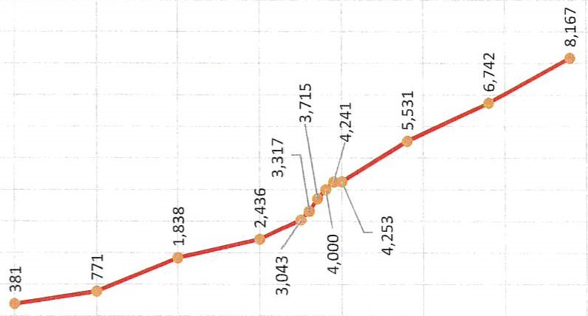
9,000
8,000
7,000 6,000
5,000
4,000
3,000
2,000

1,000
——— population
The population projection detailed in Figure I. has been developed from previous census data, actual dwelling counts for the past four years and analysis of the market vs. land availability. The projection has been compared to the 2012 Utah State population projections from the Governor's Office of Management & Budget (GOMB) and the Mountainland Association of Governments (MAG). Actual growth in Elk Ridge from 2010 to 2018 has surpassed the GOMB / MAG projection by the equivalent of approximately 5 years of growth making the projection obsolete. The GOMB / MAG projection will be revisited when it has been updated utilizing the 2020 Census results. Figure
Table 2 summarizes the population projections from GOMB and MAG.
Table 2: Other Government Entities (GOMB) & (MAG) Population Projections
Year | Population Projection
2010 | 2,436 (2010 Census)
2020 | 3,898
2030 | 4,696
2040 | 5,888
2050 | 7,100
2060 | 8,500
PLANNING AREA
The City limits currently encompass approximately 1,820 gross acres. Approximately 1,091 acres are currently developed. The City annexation boundary includes an additional 164 acres for future expansion. Table 3 and Table 4 show the land use and zoning designations and the corresponding area for the remaining developable area. Refer to Figure 2. Land use Development Capacity map.
LAND USE AND BUILD-OUT CAPACITY
In order to define potential growth areas and more accurately determine needed improvements, the City's designated land use densities are used to project future land use. These densities are listed in Table 3 and shown on Figure 2. land use Development Capacity map.

Table 3: Land Use Densities
Land Use | Land Use Density
Residential (R-1-12000) | 12,000 | sf (min. lot size)
Rural Residential (RR-I ) | 20,000 | sf (min. lot size)
Residential (R&L 1-20000) | 20,000 | sf (min. lot size)
Hillside Residential (HR-I) | 40,000 | sf (min. lot size)
Residential (R-1-20000) | 20,000 | sf (min. lot size)
Residential (R-15000) | 15,000 | sf (min. lot size)
Critical Environment (CE-2) | 5 | acres (min. lot size)
Critical Environment (CE-3) |  | 4 acres (min. lot size
Existing developments within the City were analyzed to determine the developable area percentages. To account for roads, easements, utilities, and other non-buildable areas approximately 30% of a typical residential subdivision is non-buildable. The amount of non-buildable land is less for the Critical Environment land use designation (15%) as street infrastructure is a smaller percentage of the overall development.
The future land uses were analyzed using data provided by the city to determine future growth capacity. The established land use densities shown in Table 3 were used to determine the total number of units for each land use designation at build-out. The total number of units and developable acreage for the build-out condition are shown in Table 4. With the capacity for growth and potential growth rates established. Table 5 details the population and housing growth projections side by side through build out.
Table 4: Build-out Residential Units and Develo able Acrea e
 |  |  | Total  Undeveloped  Area acres | Developable Area (%) | Total Developable  Area acres | 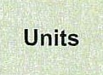
Residential (R-112000) | 0.28 | acres (min. lot size | 4.08 |  | 3 | 12
Residential (R&L 120000) | 0.46 | acres (min. lot size | 153.76 | 70% | 108 | 232
Hillside Residential (HR-I) | 0.92 | acres (min. lot size | 169.77 | 70% | 118 | 129
Residential (R15000) | 0.34 | acres (min. lot size | 49.53 | 70% |  | 101
Critical Environment (CE-3) | 1.00 | acres (min. lot size | 489.01 | 85% | 416
Totals | NIA |  | 866.15 | NIA | 679 | 927

Table 5: Population and Housing Projections
 | Population and Housing Projections
Year |  | PO ulation |  | Housing
1980 |  | 381 |  | 99
1990 |  | 771 |  | 167
2000 |  | 1 ,838 |  | 300
2010 |  | 2,436 |  | 584
2015 |  | 3,043 |  | 766
2016 |  | 3,317 |  | 834
2017 |  | 3,715 |  | 932
January 2018 |  |  | rox. 4,000 | 1 ,004
2020 |  | 4,453 |  | 1,119
2028 |  | 5,531 |  | 1 ,390
2030 |  | 5,755 |  | 1 ,446
2038 |  | 6,742 |  | 1 ,694
2040 |  | 7,015 |  | 1 ,763
2048 Build Out |  | 8,167 |  | 2,052
Table 5 Origin of Data: Census, Actual, Estimated/Projected

CHARACTERIZATION OF COMMUNITY BY CENSUS DATA 2020
POPULATION  31.0 4,972 4.0  Median Age Population Average  Household Size | HOUSING  $427,619 $1,179 96%  Median Home Median Contract 2022 Owner  Value Rent Occupied  Housing Units  (Esri) (%)
INCOME  $106,478 $32,883 $466,415  Median Per Capita Median Net  Household Income Worth Income | LOCAL ECONOMY  26 126 3,331  2018 Total 2018 Total 2018 Total  Businesses Employees Daytime  (SIC01-99) (SIC01-99) Population

