CONTENTS

10-15A SUBDIVISION APPLICATIONS 3

10-15A-1 INTENT 3

10-15A-2 SCOPE OF APPLICABILITY 3

10-15A-3 APPROVED AND RECORDED DOCUMENTS REQUIRED 3

10-15A-3.1 PENALTY FOR NONCOMPLIANCE 3

10-15A-4 DEFINITIONS 4

10-15A-5 SUBDIVISION LAND USE AUTHORITY 7

10-15A-6 SUBDIVISION APPEALS 8

10-15A-7 SUBDIVISION APPLICATION REQUIREMENTS 8

10-15A-8 EXCEPTIONS TO SPECIFIC APPLICATION REQUIREMENTS 12

10-15A-9 PRE-APPLICATION MEETING 13

10-15A-10 NOTICE TO AFFECTED ENTITIES 14

10-15A-11 REVIEW 14

10-15A-12 APPROVAL 18

10-15A-13 POST-APPROVAL ACTIONS 18

10-15A-14 AMENDING A SUBDIVISION 19

10-15A-15 LOT LINE ADJUSTMENTS 20

10-15B SUBDIVISION IMPROVEMENTS 20

10-15B-1 REQUIRED IMPROVEMENTS 21

10-15B-2 RESPONSIBLE PARTY; EXCEPTIONS: 27

10-15B-3 COMPLETION OF IMPROVEMENTS 27

10-15B-4 IMPROVEMENT GUARANTEES, COMPLETION ASSURANCES, AND WARRANTIES 27

10-15C DESIGN STANDARDS AND REQUIREMENTS 28

10-15C-1: GENERALLY: 28

10-15C-2: STREETS AND ROADS: 29

10-15C-3: BLOCKS: 32

10-15C-4: LOTS; DESIGN STANDARDS: 32

10-15C-5: CUL-DE-SACS: 33

10-15C-6: EXISTING CONDITIONS AND HAZARDS: 34

10-15C-7: LOTS ABUT ON PUBLIC STREET; DOUBLE FRONTAGE LOTS PROHIBITED, EXCEPTIONS: 34

10-15C-8: WORK DONE BY ENGINEER OR SURVEYOR: 34

10-15C-9: DRAWINGS OF RECORD REQUIRED: 34

10-15C-10: ADJUSTMENTS TO STANDARDS PERMITTED; PROCEDURE: 34

10-15C-11: DERELICT PARCELS PROHIBITED: 35

10-15C-12: UNIMPROVED RESIDUAL LOTS NOT PERMITTED: 35

10-15C-13: WATER RIGHTS CONVEYED TO CITY; EXCEPTIONS: 35

10-15C-14: REIMBURSEMENT FOR OFF SITE IMPROVEMENTS; CONDITIONS AND LIMITATIONS: 36

10-15C-15: DWELLING LOCATION: 36

10-15C-16: ACCESS DRIVEWAYS: 36

# 10-15A SUBDIVISION APPLICATIONS

## 10-15A-1 INTENT

The intent of this Chapter is as follows:

1. To facilitate the orderly development of the City.
2. To implement the City’s major street plan.
3. To facilitate the development of a safe and efficient street system.
4. To facilitate the orderly transfer of the ownership of building sites in a manner consistent with state law.
5. To ensure the providing of adequate water, sewer, drainage, utilities, and other services to developing areas of the City.
6. To establish the rights, duties and responsibilities of subdividers with respect to the development of land within the City.
7. To promote the health and general welfare of the City of Elk Ridge’s current and future residents.

## 10-15A-2 SCOPE OF APPLICABILITY

This Chapter applies to all applications or petitions to subdivide land in the City. The requirements of this Chapter do not apply retroactively to subdivision applications or petitions that were approved by the City prior to the enactment of this ordinance.

## 10-15A-3 APPROVED AND RECORDED DOCUMENTS REQUIRED

1. A subdivision of land is not valid unless its governing document is approved by the Land Use Authority and properly recorded in the County Recorder’s Office.
2. No person shall subdivide any tract of land within the incorporated limits of the City—nor shall any person sell, exchange, purchase or otherwise convey a parcel of land which is part of a larger tract, if such sale or agreement would have the effect of creating a subdivision—unless and until a final plat, prepared in accordance with the provisions of this development code, shall have been first approved by the Land Use Authority and recorded in the Office of the County Recorder in accordance with the provisions of this Chapter.

## 10-15A-3.1 PENALTY FOR NONCOMPLIANCE

It is unlawful to transfer ownership of any parcel of land pursuant to an invalid subdivision. The City may, in its discretion, void such transfers and impose on the transferor a Class B misdemeanor.

## 10-15A-4 DEFINITIONS

The following words and phrases, as used in this Chapter, shall have the following meanings. Words and phrases not defined here have the meaning expressed in 1-3-2 of Elk Ridge City Code.

1. "Association" means the same as that term is defined in Utah Code Section 57-8a-102, as amended. "Association" or "homeowner association" does not include an association created under Chapter 8, Condominium Ownership Act.
2. “Common area" means property that an Association (as defined in Utah Code Section 57-8a-102):
   1. Owns;
   2. Maintains;
   3. Repairs; or
   4. Administers
3. “Common area and facilities” means:
   1. The land included within the condominium project, whether leasehold or in fee simple;
   2. The foundations, columns, girders, beams, supports, main walls, roofs, halls, corridors, lobbies, stairs, stairways, fire escapes, entrances, and exits of the building;
   3. The basements, yards, gardens, parking areas, and storage spaces;
   4. The premises for lodging of janitors or persons in charge of the property;
   5. Installations of central services such as power, light, gas, hot and cold water, heating, refrigeration, air conditioning, and incinerating;
   6. The elevators, tanks, pumps, motors, fans, compressors, ducts, and in general all apparatus and installations existing for common use;
   7. Such community and commercial facilities as may be provided for in the declaration; and
   8. All other parts of the property necessary or convenient to its existence, maintenance, and safety, or normally in common use.
4. “Facility owner” means, in the context of water conveyance, an individual, entity, mutual water company, or unincorporated organization:
   1. Operating a water conveyance facility;
   2. Owning any interest in a water conveyance facility; or
   3. Having a property interest in real property based on the presence of the water conveyance facility located and operating on the real property.
5. "Improvement plan": a plan to complete permanent infrastructure on the subdivision that is essential for the public health and safety, that is required for human occupation, or that is required by applicable law and that an applicant must install in accordance with public installation and inspection specifications for public improvements and as a condition of recording a subdivision plat.
6. “Improvement warranty” or “warranty” in the context of completed improvements means an applicant’s unconditional warranty that the applicant’s installed and accepted landscaping or infrastructure improvement complies with the Town’s written standards for design, materials, and workmanship; and will not fail in any material respect, as a result of poor workmanship or materials, within the improvement warranty period.
7. “Land use application”: an application required by the City and submitted by a land use applicant to obtain a land use approval; this does not mean an application to enact, amend, or repeal a land use regulation.
8. "Land use authority": An individual, board, or commission appointed or employed by the City to make land use decisions. “Land Use Authority” includes any appropriately authorized designees. The “Land Use Authority” for various processes or applications may differ.
9. “Lot”: A tract of land, regardless of any label, that is created by and shown on a subdivision plat that has been recorded in the office of the county recorder.
10. “Lot line adjustment” means the process of combining two or more lawful existing lots into a fewer number of total lots than existed prior to the boundary line adjustment; or the moving of a boundary line between two or more lots where the total number of lots after the change remains the same.
11. “Parcel”: See “Parcel” as defined in § 8-6-3 of the City’s code.
12. “Plat”: An instrument subdividing property into lots as depicted on a map or other graphic representation of land that a licensed professional land surveyor makes and prepares in accordance with §10-9a-603 or §57-8-13 of Utah State Code (as amended).
13. “Public landscaping improvement” means landscaping that an applicant is required to install to comply with published installation and inspection specifications for public improvements that:
    1. Will be dedicated to and maintained by the Town; or
    2. Are associated with and proximate to trail improvements that connect to planned or existing public infrastructure.
14. “State engineer's inventory of canals" means the state engineer's inventory of water conveyance systems established in Utah Code § 73-5-7.
15. “Subdivision”: Any land that is divided, subdivided, or proposed to be divided into two or more lots or other division of land for the purpose, whether immediate or future, for offer, sale, lease, or development either on the installment plan or upon any and all other plans, terms, and conditions.
    1. Subdivision includes:
       1. The division or development of land, whether by deed, metes and bounds description, devise and testacy, map, plat, or other recorded instrument, regardless of whether the division includes all or a portion of a parcel or lot; and
       2. Except as provided below, divisions of land for residential and nonresidential uses, including land used or to be used for commercial, agricultural, and industrial purposes.
    2. Subdivision does not include:
       1. A bona fide division or partition of agricultural land for the purpose of joining one of the resulting separate parcels to a contiguous parcel of unsubdivided agricultural land, if neither the resulting combined parcel nor the parcel remaining from the division or partition violates an applicable land use ordinance;
       2. A boundary line agreement recorded with the Office of the County Recorder between owners of adjoining parcels adjusting the mutual boundary in accordance with §10-9a-524 of Utah State Code (as amended) if no new parcel is created;
       3. A recorded document, executed by the owner of record revising the legal descriptions of multiple parcels into one legal description encompassing all such parcels or joining a lot to parcel;
       4. A boundary line agreement between owners of adjoining subdivided properties adjusting the mutual lot line boundary in accordance with §10-9a-524 and §10-9a-608 of Utah State Code (as amended) if no new dwelling lot or housing unit will result from the adjustment and the adjustment will not violate any applicable land use ordinance;
       5. A bona fide division of land by deed or other instrument if the deed or other instrument states in writing that the division is in anticipation of future land use approvals on the parcel or parcels does not confer any land use approvals, and has not been approved by the land use authority;
       6. A parcel boundary adjustment;
       7. A lot line adjustment;
       8. A joining of one or more lots to a parcel;
       9. A road, street, or highway dedication plat;
       10. A deed or easement for a road, street, or highway purpose; or
       11. Any other division of land authorized by law.
16. "Water conveyance facility" means a ditch, canal, flume, pipeline, or other watercourse used to convey water used for irrigation or storm water drainage and any related easement for the ditch, canal, flume, pipeline or other watercourse. “Water conveyance facility” does not mean a ditch, canal, flume, pipeline, or other watercourse used to convey water used for culinary or industrial water, or any federal water project facility.

## 10-15A-5 SUBDIVISION LAND USE AUTHORITY

1. The Land Use Authority for preliminary applications under this Chapter is the Planning Commission. For purposes of subdivision applications, the Planning Commission shall be responsible for the following, but may delegate any responsibility to City staff:
   1. Rendering land use decisions related to preliminary applications.
   2. Reviewing preliminary applications in an impartial manner and according to the standards and deadlines described in this Chapter.
   3. Holding a public hearing for preliminary applications (when needed).
   4. Providing feedback to applicants on their preliminary applications.
   5. Scheduling and holding a pre-application meeting with potential applicants (when requested).
   6. Keeping application forms (both preliminary and final) and related informational material up to date and publicly accessible and distributing such forms and materials to potential applicants. This task is delegated to City staff by default.
   7. Providing notice to entities and parties as required by this Chapter. This task is delegated to City staff by default.
   8. Ensuring that documents are properly recorded with the County after final approval as required by this Chapter. This task is delegated to City staff by default.
2. The Land Use Authority for final applications under this Chapter is the Subdivision Review Committee (SRC). For purposes of subdivision applications, the Subdivision Review Committee shall be responsible for and is granted the power to effectuate the following:
   1. Rendering land use decisions related to final applications.
   2. Reviewing final applications in an impartial manner and according to the standards and deadlines described in this Chapter.
   3. Signing final application approvals as required by this Chapter.
3. The Subdivision Review Committee shall be organized as follows:
   1. Membership shall include one member of the City Council, one members of the Planning Commission, the City Engineer, the City Manager, and the Public Works Director.
   2. The SRC may meet informally on an as-needed basis and shall make all application approvals through unanimous vote.
      1. Three members of the Subdivision Review Committee present at a meeting of the committee constitutes a quorum with power to act.
4. As subdivision application decisions are administrative, not legislative, the Planning Commission and SRC are respectively authorized to make land use decisions as described by this Chapter without City Council approval.

## 10-15A-6 SUBDIVISION APPEALS

Appeals of land use decisions under this Chapter (e.g., approval or denial of an application) shall be made according to 2-2-4.

## 10-15A-7 SUBDIVISION APPLICATION REQUIREMENTS

1. The City shall not approve, nor shall a party record, any plat or other creating instrument for a new subdivision unless the party has properly applied under this Chapter and received both a preliminary approval from the Planning Commission and a final approval from the Subdivision Review Committee.
2. To be considered complete, a **preliminary** subdivision application must include at least the following elements:
   1. **An approved land use application** that describes how the property will be used after it is subdivided.
      1. If the intended use is permitted by right under City ordinances, the land use application must include citations to the specific ordinance(s) that the applicant believes authorizes the intended use.
      2. If the intended use requires a conditional use permit or is otherwise conditioned on City approval, the land use application must include an *approved*, City-issued permit authorizing the intended use. Should an applicant seek a use permit concurrently with a related subdivision application, the subdivision application shall be considered incomplete until the use permit is issued.
      3. If the intended use is prohibited under City ordinances and requires a variance, the land use application must include an *approved*, City-issued variance authorizing the intended use. Should an applicant seek a variance concurrently with a related subdivision application, the subdivision application shall be considered incomplete until the variance is issued.
   2. **A preliminary plat**, unless exempt under Section 10-15A-8. The preliminary plat must be drawn to scale, in detail, and in accordance with generally accepted surveying standards and the acceptable filing standards of the County Recorder’s Office. The preliminary plat must include:
      1. The proposed subdivision name, which must be distinct from any subdivision name on a plat recorded in the County Recorder's office.
      2. The boundaries, course, and dimensions of all proposed parcels. All parcels on the plat must comply with the lot size requirements of Section 10-15C.
      3. The lot or unit reference; block or building reference; street or site address; street name or coordinate address; acreage or square footage for all parcels, units, or lots; and length and width of the blocks and lots intended for sale.
      4. Every existing right-of-way and recorded easement located within the plat for underground, water, and utility facilities.
      5. Any known and unrecorded water conveyance facility located, entirely or partially, within the plat.
      6. Whether any parcel is intended to be used as a street or for any other public use.
      7. Whether any parcel is reserved or proposed for dedication for a public purpose.
      8. If the application is for a condominium plat, the requirements found in Utah Code §57-8-13, as amended.
   3. **Studies and reports**:
      1. A traffic study completed by a qualified Surveyor if one is required by an applicable UDOT Access Management Plan.
         1. Such plans are typically required when a plat abuts a road maintained by UDOT. It is the responsibility of the subdivider to know whether their application will require such a plan.
      2. A water report from a qualified expert, regarding flood risks and stormwater needs.
      3. A soils report from a qualiﬁed soils engineer, identifying the types of soils within the proposed subdivision area and identifying any soils constraints on the proposed subdivision.
      4. Any zoning district requirement that
      5. Any other study or report reasonably necessary to assess the impact of the proposed subdivision on the City or to assess compliance with City ordinances – particularly those parcels that the City has zoned as “CE-2 Critical Environmental” and/or “HR-1 Hillside Residential”.
   4. **An improvement plan**, created in accordance with applicable portions of Chapters 10-15B and 10-15C of this Title, for all public improvements proposed by the applicant or required by City ordinances.
      1. In addition to the requirements in Chapters 10-15B and 10-15C, the improvement plan must contain an engineer’s estimate of the cost of completing the required improvements.
   5. **Certifications**, including:
      1. An affidavit from the applicant certifying that the submitted information is true and accurate.
      2. The signature of each owner of record of land described on the preliminary plat, signifying their consent to the preliminary subdivision application and their intent to dedicate portions of the preliminary plat to the public as described in the application.
      3. Certification that the surveyor who prepared the plat:
         1. Holds a license in accordance with Utah Code 58-22; and
         2. Either
            1. Has completed a survey of the property described on the plat in accordance with state requirements and has verified all measurements; or
            2. Has referenced a record of survey map of the existing property boundaries shown on the plat and verified the locations of the boundaries; and
         3. Has placed monuments as represented on the plat.
   6. **Fees:** Payment of any preliminary-application-processing fees required by the City (see the City’s Fee Schedule, 10-4-4) and the cost of any legal or engineering review of the application that the City deems necessary.
   7. **Copies:** A paper copy of all plans with 11x17 as a minimum size andan electronic copy of all plans in PDF format.
3. To be considered complete, a **final** subdivision application must include the following:
   1. The Planning Commission’s **approval of the applicant’s preliminary application**, given within the last 365 calendar days.
   2. **The approved land use application** that was accepted during the preliminary application review process.
   3. **A final plat**, unless exempt under Section 10-15A-8. The final plat should be the version of the preliminary plat approved by the Planning Commission during the preliminary application review process, plus any other immaterial changes (e.g., formatting) necessary to comply with the recording requirements of the County Recorder’s Office.
   4. **A completion assurance** for all public improvements required by the improvement plan approved during the preliminary application review, or a statement that such improvements will be completed before development occurs on the proposed subdivision and before the applicant records the plat, as required by Chapter 10-15B of this Title.
   5. **Certifications**, including:
      1. A Title Report or Title Insurance Policy for the land to be subdivided verifying property ownership.
      2. A Tax Clearance Certificate from the state indicating that all taxes, interest, and penalties owing on the land have been paid.
      3. An affidavit from the applicant certifying that the submitted information is true and accurate.
      4. The signature of each owner of record of land described on the plat, signifying their consent to the final subdivision application and their dedication and approval of the final plat.
      5. Certification that the surveyor who prepared the plat:
         1. Holds a license in accordance with Utah Code 58-22; and
         2. Either
            1. Has completed a survey of the property described on the plat in accordance with state requirements and has verified all measurements; or
            2. Has referenced a record of survey map of the existing property boundaries shown on the plat and verified the locations of the boundaries; and
         3. Has placed monuments as represented on the plat.
   6. **Binding dedication documents**, including:
      1. As applicable, formal, irrevocable offers for dedication to the public of streets, City uses, utilities, parks, easements, and other spaces.
      2. If the plat is to be part of a community association, signed and binding documents conveying to the association all common areas.
   7. **Copies**, including:
      1. One electronic copy of the final plat in AutoCAD format (DWG or DXF), Geodatabase format (GDB), or Shapeﬁle format (SHP), with a projection assigned to the ﬁle(s) and with the proper metadata that describes what coordinate system/projection the data is assigned to; and
      2. A PDF document of the final plat and all other plans and supporting documents required by this Chapter.
      3. A printed copy of the final plat on mylar for recording.
   8. Payment of any final-application-processing fees required by the City (see the City’s Fee Schedule, 10-4-4).
4. The Planning Commission (or City staff, as delegated) shall produce, maintain, and make available to the public a list of the specific items that comprise complete preliminary and final applications, in accordance with this ordinance, and a breakdown of any fees due upon submission or approval of the applications.
5. The Land Use Authority may require, and the applicant shall provide, additional information beyond the requirements of this Section or those published by the City relating to an applicant’s plans to ensure compliance with City ordinances and approved standards and specifications for construction of public improvements and to protect the health and safety of City residents.
6. Notwithstanding 10-15A-7.E, the Land Use Authority may waive specific application requirements on a case-by-case basis and consider an application “complete”, whether during a pre-application meeting, during the application review period, or both.

## 10-15A-8 EXCEPTIONS TO SPECIFIC APPLICATION REQUIREMENTS

1. **Agricultural Land**:
   1. Applications to subdivide agricultural land are exempt from the preliminary and final plat requirements (but not the other application requirements) of Section 10-15A-7 if the resulting parcels:
      1. Qualify as land in agricultural use under Utah Code §59-2-502;
      2. Meet the minimum size requirement of applicable City land use ordinances; and
      3. Are not used and will not be used for any nonagricultural purpose.
   2. For subdivision applications for which this exception applies, an applicant may submit to the City—in place of a plat—a record of survey map that illustrates the boundaries of the parcels.
   3. If the City approves a subdivision application based on a record of survey map, the applicant shall record the map, signed by the City, with the County Recorder’s Office. This shall be done in the same manner as is done for a plat under Section 10-15A-13.
   4. If a parcel resulting from a subdivision under this exception ever ceases to be used for agriculture, the subdivision shall become invalid. The City may, in its discretion, impose the penalty in Section 10-15A-3.1 and/or require a subdivision amendment before issuing a building permit.
2. **Minor Subdivisions**:
   1. Applications to subdivide land are exempt from the preliminary and final *plat* requirements (but not the other application requirements) of Section 10-15A-7 if the subdivision:
      1. Results in no more than three (3) lots;
      2. Is not traversed by the mapped lines of a proposed street (as shown in the Elk Ridge General Plan), City easement, or any other land required for public purposes;
      3. Has been approved by the culinary water authority and the sanitary sewer authority; and
      4. Is located in a zoned area.
   2. For subdivision applications for which this exception applies, an applicant may submit to the City—in place of a plat—both:
      1. A record of survey map that illustrates the boundaries of the parcels; and
      2. A legal metes-and-bounds description that describes the parcels illustrated by the survey map.
   3. If the City approves a subdivision application based on a record of survey map and metes-and-bounds description, the applicant shall record the map and description, signed by the City, with the County Recorder’s Office. This shall be done in the same manner as is done for a plat under Section 10-15A-13, except that the City shall also provide the notice required in Utah Code §10-9a-605(1).
3. **Development Agreements**:
   1. The City Council is hereby authorized to enter into development agreements at the request of subdividers or developers in order to more fully set forth the terms and conditions of approval of a specific subdivision project, the extent of the understandings between the City and the subdivider regarding the scope of any shared responsibility in the construction of improvements, and similar matters relating to the approval of a specific subdivision project.
   2. Subdivisions platted in a valid development agreement are exempt from the application requirements (Section 10-15A-7) and review and approval requirements (Sections 10-15A-11 and 10-15A-12) of this Chapter.
   3. Clauses in a valid development agreement with the City superseded all conflicting requirements in this Title, except where a clause in the development agreement poses a substantial danger to the health and safety of City residents.

## 10-15A-9 PRE-APPLICATION MEETING

1. A party intending to submit a subdivision application under this Chapter may request a pre-application meeting with the Planning Commission or other City staff for the purpose of reviewing any element of the party’s proposed subdivision application (preliminary or final). The proposed application need not be complete for purposes of this meeting and may—if the party desires—be limited to a concept plan.
   1. If a party requests a pre-application meeting, the City shall schedule the meeting within 15 business days after the request. The meeting shall be scheduled at the earliest convenient opportunity, and, at the option of the party requesting the meeting, shall occur within 20 business days after scheduling.
   2. The Planning Commission or delegated City staff shall conduct the meeting, provide feedback on materials as requested by the party, and shall provide or have available on the City website the following at the time of the meeting:
      1. Copies of applicable land use regulations,
      2. A complete list of standards required for the project, and
      3. Relevant application checklists.

## 10-15A-10 NOTICE TO AFFECTED ENTITIES

1. Within 15 calendar days after receiving a complete subdivision application under this Chapter, City staff shall provide written notice of the proposed subdivision to the facility owner of any known water conveyance facility located, entirely or partially, within 100 feet of the subdivision plat.
   1. To determine whether any water conveyance facility is located within 100 feet of a proposed subdivision, City staff shall review information:
      1. From the facility owner under Utah Code §10-9a-211, using mapping-grade global positioning satellite units or digitized data from the most recent aerial photo available to the facility owner;
      2. From the state engineer's inventory of canals; or
      3. From a licensed surveyor who has consulted with a representative of an existing water conveyance facility that services an area near the land the application concerns.
2. To give water conveyance facilities time to provide feedback on subdivision applications, the Land Use Authority shall not approve a preliminary (or related final) subdivision application under this Chapter sooner than 20 calendar days after the applicant submits a complete application. This waiting period does not apply to revised applications the applicant may submit during the application review process.
   1. A water conveyance facility owner’s failure to provide comments to the Land Use Authority about a subdivision application does not affect or impair the Land Use Authority’s authority to approve the subdivision application.

## 10-15A-11 REVIEW

1. The Land Use Authority shall review all subdivision applications in accordance with the requirements of this Section before approving or denying those applications.
2. For both preliminary and final applications, the review process begins when an applicant submits a complete application.
   1. The Land Use Authority shall not review an incomplete subdivision application, except to determine whether the application is complete.
   2. If the Land Use Authority determines that an application is incomplete, it shall notify the applicant of the incompleteness, highlighting any insufficiencies and explaining that the application will not be reviewed until it is complete.
3. For both preliminary and final applications, after the applicant submits a complete application, the Land Use Authority shall review and provide feedback to the applicant in a series of “review cycles.”
   1. A review cycle consists of the following phases:
      1. Phase #1: The applicant submits a complete application (or, if after the first cycle, submits a revised version of the complete application).
      2. Phase #2: The Land Use Authority reviews the application in detail and assesses whether the application conforms to local ordinances.
      3. Phase #3: The Land Use Authority responds to the applicant, citing any missing requirements or areas of noncompliance and providing a detailed list of necessary revisions to the applicant. For any required modification or addition to the application or request for more information, the Land Use Authority shall be specific and include citations to ordinances, standards, or specifications that require the modification or addition and shall provide the applicant with an index of all requested modifications or additions.
      4. Phase #4: The applicant revises the application, addressing each comment or requirement the Land Use Authority made. The applicant must submit both revised plans and a written explanation in response to the City’s review comments, identifying and explaining the applicant’s revisions and reasons for declining to make revisions, if any. This written explanation must be comprehensive and specific, including citations to applicable standards and ordinances and an index of requested revisions or additions for each required correction. If the applicant fails to respond to a comment made by the Land Use Authority in its review, the review cycle is not complete and will remain open until the applicant addresses all comments.

|  |  |  |  |  |
| --- | --- | --- | --- | --- |
| **Table 10-15A-11 – Review Cycles, Hearings, and Timelines by Subdivision Use Type** | | | | |
| *Use Type* | *Approval Stage* | *Max Review Phases* | *Max Public Hearings* | *City Turnaround Deadline\*\** |
| 1-2 Family Residential* | Preliminary | 4 | 1 | 15 Business Days |
| Final | 2 | 0 | 15 Business Days |
| All Other Uses | Preliminary | 6 | 2 | 30 Business Days |
| Final | 1 | 0 | 30 Business Days |
| *Includes single-family homes, duplexes, and townhomes.  **Describes the total time (per review cycle) the City may take to complete both Phase #2 and Phase #3. | | | | |

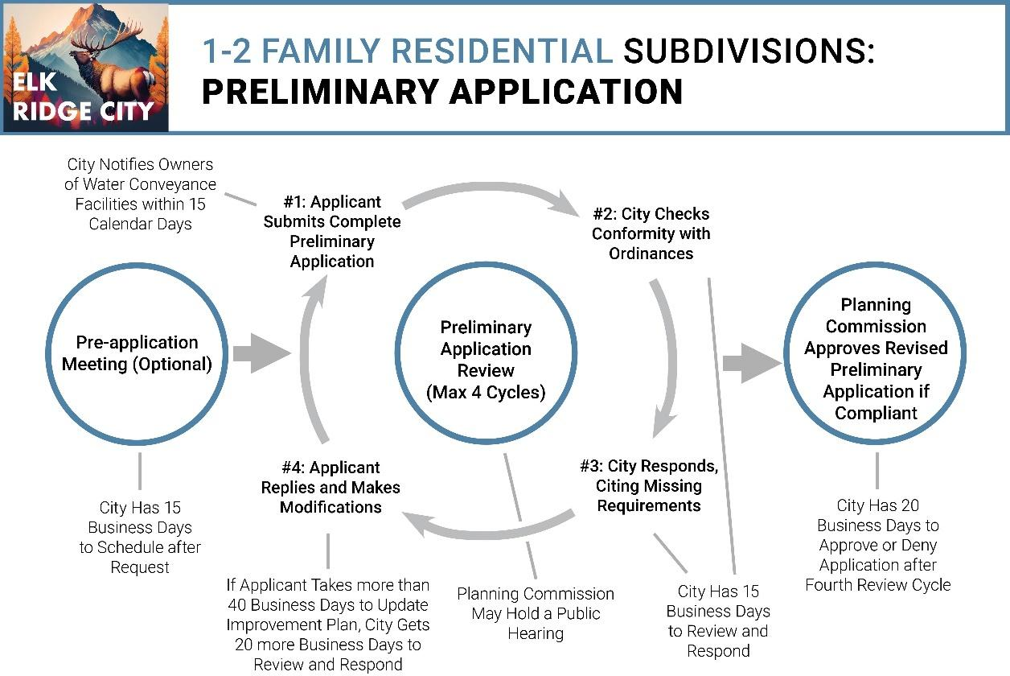

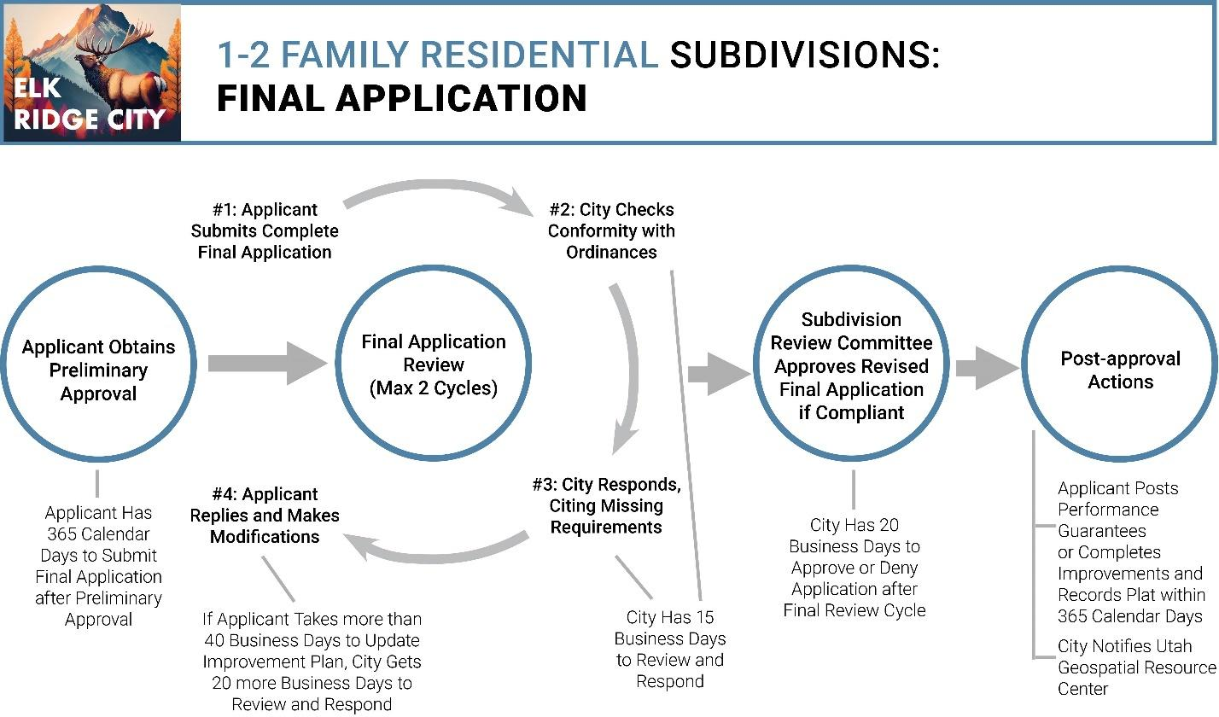

1. A Land Use Authority (and other City representatives or agents) shall adhere to the maximum number of review cycles and the review deadlines described in Table 10-15A-11, except as described below. If no further revisions are needed, the Land Use Authority may end the review process early and approve or deny the preliminary or final application.
   1. This provision notwithstanding, for any subdivision application that affects property within an identified geological hazard area, the City is exempt from limits on the number of permitted review cycles and the City’s deadlines for reviewing and responding (Phases #2 and #3).
   2. If the applicant makes a material change to a preliminary or final application not requested by the City at any point in the review process, the Land Use Authority may restart the review process, but only with respect to the portion of the application that the material change substantively affects.
   3. For both preliminary applications, if an applicant takes longer than 40 business days to submit a revised subdivision improvement plan responding to the City’s requests for modifications and additions (in Phases #1 and #4), the City shall have an additional 20 business days to review and respond to the revised application (Phases #2 and #3 of the next review cycle or issuing an approval decision).
   4. For both preliminary and final applications, if an applicant takes longer than 180 calendar days to submit a revised application and respond to the City’s requests for modifications and additions (Phases #1 and #4), the application shall, at the option of the Land Use Authority, expire. If an application expires, the applicant must restart the subdivision application process.
   5. If the applicant has not submitted a final application within 365 calendar days after the Land Use Authority notifies the applicant that it has approved the related preliminary application, the related preliminary approval shall expire. In this case, the applicant shall not submit a final application until the Land Use Authority has issued a new preliminary application approval.
2. When a preliminary or final application’s review period ends, the Land Use Authority shall approve or deny the respective preliminary or final application within 20 business days.
   1. If the Land Use Authority has not approved or denied the application within 20 business days after the allotted review cycles are complete, the applicant may request a decision. After such a request, the City shall, within 10 business days:
      1. For a dispute arising from the subdivision improvement plans, assemble an appeal panel in accordance with Utah Code §10-9a-508(5)(d) to review and approve or deny the revised set of plans; or
      2. For a dispute arising from the subdivision ordinance review, advise the applicant, in writing, of the deficiency in the application and of the right to appeal the determination to the designated Appeal Authority.
3. After the Land Use Authority provides comments in the last allotted review cycle for a final application, the City shall not require further modifications or corrections to the application unless those modifications or corrections are necessary to protect public health and safety or to enforce state or federal law or unless the review cycle reset due to the applicant making a material change that the Land Use Authority did not request.
   1. With the exception of modifications or corrections that are needed to protect public health and safety, that are needed to enforce state or federal law, or that arise from the review cycle being reset, the City waives noncompliant subdivision-related requirements that the Land Use Authority does not identify during the review process.
   2. The applicant shall make reasonable changes, unless prohibited otherwise by a contract or deed, to the subdivision application to accommodate the water conveyance facility to the extent required by Utah Code §73-1-15.5.
4. The Land Use Authority may conduct one or more public hearings (up to the number described in Table 10-15A-11) during the review period for a preliminary subdivision application.
   1. The purpose of these public hearings is to ask questions of the applicant and receive commentary on the technical aspects of the application from affected entities, interested parties, and the public.
   2. If the Land Use Authority elects to hold a public hearing, the hearing must occur before the end of the Land Use Authority’s preliminary review period (end of Phase #3 of the last preliminary review cycle). Scheduling issues shall not extend the review and approval deadlines in this Chapter.
   3. The Land Use Authority shall not hold a public hearing during the review period for a final subdivision application.
5. Other chapters of this Title notwithstanding, the Land Use Authority shall approve or deny preliminary and final applications under this Chapter after reviewing the complete applications as described in this Section.

## 10-15A-12 APPROVAL

1. The respective Land Use Authorities shall approve any complete preliminary and final applications made under this Chapter that comply with applicable City ordinances and Utah State Code.
2. The respective Land Use Authorities shall issue all approvals in writing. After approval, a representative of the SRC shall certify the approved final plat, either by signing the plat directly or by attaching a signed certification to the plat.

## 10-15A-13 POST-APPROVAL ACTIONS

1. The applicant shall record the approved final plat with the County Recorder’s Office within 365 calendar days after the Land Use Authority approves the final application, provided that the applicant has completed any improvements or posted any performance guarantee required by City ordinances or described in the approved improvement plan. The applicant shall not record the approved final plat until such improvements are completed or guaranteed in compliance with City ordinances and the approved improvement plan.
   1. An approved final plat not properly recorded within the timeline specified in this provision is void, unless the SRC approves an extension.
2. City staff shall submit to the Utah Geospatial Resource Center (so the subdivision can be included in the 911 database), within 30 calendar days after the final application is approved, either:
   1. An electronic copy of the approved final plat; or
   2. Preliminary geospatial data that depict any new streets and situs addresses proposed for construction within the bounds of the approved final plat.

## 10-15A-14 AMENDING A SUBDIVISION

1. The City Council may vacate a subdivision or a portion of a subdivision by enacting an ordinance to that effect that describes the subdivision or the portion being vacated and recording that ordinance in the County Recorder's Office.
2. A property owner or agent of a property owner may correct minor typographical or clerical errors in a document of record by filing with the County an affidavit or other appropriate instrument. This provision does not apply to changing the name of a subdivision, which requires a material amendment described in the following provisions.
3. A fee owner of land in a platted subdivision may request a material subdivision amendment by filing a written petition with the Planning Commission. This petition must meet all the requirements for a preliminary subdivision application specified in Section 10-15A-7, with the following changes:
   1. The preliminary plat (or the record of survey map, if applicable) should:
      1. Depict only the portion of the subdivision that is proposed to be amended;
      2. Include a plat name distinguishing the amended plat from the original plat;
      3. Describe the differences between the amended plat and the original plat;
      4. Include references to the original plat; and
      5. Meet all the other plat requirements specified in Section 10-15A-7.
   2. The petition must additionally include the name and address of each property owner affected by the petition and the signature of each of those property owners who consents to the petition.
   3. The petitioner must include with the petition envelopes addresses to each property in the subdivision.
4. Upon receipt of an amendment petition, the Planning Commission (or City staff, as delegated) shall provide notice of the petition to:
   1. Each utility provider that services a parcel of the subdivision. The City shall not approve an amendment petition until at least 10 calendar days after noticing these utility providers. The City may notify the utility providers in any effective manner (email, mail, etc.).
   2. Each property owner in the subdivision. The City shall notify these property owners by mail.
5. The Planning Commission shall hold a public hearing before approving an amendment petition and within 45 calendar days after the day on which the petition is submitted if:
   1. A property owner objects in writing to the amendment within 10 days of the City notifying the property owner by mail, or
   2. Not every property owner in the subdivision has signed the revised plat.
6. Notwithstanding Section 10-15A-14, the Planning Commission need not hold a public hearing if notice has been given to adjoining property owners in accordance with any applicable local ordinance and the petition seeks to:
   1. Join two or more of the petitioner’s contiguous lots;
   2. Subdivide one or more of the petitioner's lots;
   3. Adjust the lot lines of adjoining lots or between a lot and an adjoining parcel if the fee owners of each of the adjoining properties join in the petition, regardless of whether the properties are located in the same subdivision;
   4. On a lot owned by the petitioner, adjust an internal lot restriction imposed by the local political subdivision; or
   5. Alter the plat in a manner that does not change existing boundaries or other attributes of lots within the subdivision that are not owned by the petitioner or designated as a common area.
7. If the Planning Commission approves the amendment petition, the Planning Commission shall sign the amended plat in the manner described in Section 10-15A-12, and the petitioner shall record the plat, subject to the completion or guarantee of any improvements, as described in Section 10-15A-13.

## 10-15A-15 LOT LINE ADJUSTMENTS

1. The fee owners of two parcels may petition to adjust the lot line separating the parcels without a subdivision amendment. Such a petition shall include:
   1. A record of survey map and a metes-and-bounds description showing the adjustment.
   2. An explanation of the reason for the adjustment.
   3. Signatures from all the parcel owners involved in the adjustment.
   4. Any other information the Planning Commission requests.
2. If the adjustment will not result in a violation of a land use ordinance or an adverse development condition, the Planning Commission shall approve the petition.
3. If the adjustment is approved, the Planning Commission shall sign the record of survey map and accompanying metes-and-bounds description, and the petitioner shall record the document in the County Recorder’s Office.

# 10-15B SUBDIVISION IMPROVEMENTS

## 10-15B-1 REQUIRED IMPROVEMENTS

**Inclusion in Improvement Plan:** The placement, size and type of all required improvements shall be shown in the improvement plan accompanying a preliminary subdivision application. Such improvement plan shall include engineering drawings relating to the improvements.

**Required Improvements:** The following improvements are required for all subdivisions and development in the City, unless specifically waived by ordinance or the Land Use Authority. All improvements shall meet minimum City standards for design and quality of materials and shall be installed in accordance with minimum City standards and specifications and current APWA standard plans and specifications, as directed by the City.

1. Streets And Roads:
   1. Improvements: All streets shown on the final plat for dedication to the City and any existing street, whether or not shown on the final plat, which is contiguous and provides access to any lot in a subdivision shall be improved in conformance with the applicable cross section and construction standards as set forth in the City development and construction standards.
   2. Asphalt Layer Thickness: All streets shall be installed with a two and one-half inch (21/2") surface layer of asphalt at the time of initial development construction. At such a time that ninety percent (90%) or more of the lots have been permitted for site construction, or not more than two (2) years from the date of initial performance guarantee, the developer shall be responsible for any and all street repairs necessary and the installation of a one inch (1") asphalt overlay on all parts of all roads in and associated with the subdivision. At no time shall a street in a subdivision be completed with a street surface asphalt layer being thinner than three and one-half inches (31/2") total thickness.
   3. Street Grade: No major collector/arterial street shall have a grade of more than eight percent (8%) and no local street shall have a grade of more than ten percent (10%), except that the City Council may approve up to an additional two percent (2%) grade for short stretches of roadway where, in its opinion, the eight percent (8%)/ten percent (10%) standards would result in undesirable extra earthwork or circuitous routes and that the proposed steep grade section will not result in the establishment of a hazardous condition. It is the responsibility of the developer to present evidence that the additional allowance in grade is desirable. The City Engineer shall provide recommendation regarding hazardous conditions and any other concerns on the proposed steep grade sections. (Ord. 06-19, 11-28-2006)
2. Sidewalks And Trails:
   1. Sidewalks; Compliance: Sidewalks shall be provided along both sides of streets, at the developer's expense, and in compliance with the detailed performance standards of "city of Elk Ridge construction specifications and standards". Sidewalks are "required improvements", subject to the guarantee provisions of chapter 16 of this title.
   2. Sidewalks; Infill Areas/Agricultural Zones: Sidewalks may not be required in infill areas not required to have curb and gutter. They are also not required in agricultural zones. The city council can require sidewalk in infill or agricultural zones if deemed appropriate. Such determination may be made if lot sizes, traffic patterns, wider roads or other related design factors support installation of sidewalks.
   3. Sidewalks; Placement: Notwithstanding other provisions of this title, the city council may determine in the development agreement that sidewalks will not be required on one or both sides of the street. Such determination may be made if lot sizes, traffic patterns, wider roads or other related design factors support a more flexible approach. If sidewalks are not required, the city council may specify the completion of other public facilities in lieu of sidewalks.
   4. Improved Trails: Developments shall provide improved trails constructed to "city of Elk Ridge construction specifications and standards" for bicycle/pedestrian use which connect the development to other public facilities such as parks or the major existing and planned trails established in the city's general plan. The trail requirement also is extended to cul-de-sacs that require a trail easement connecting neighborhoods. Trails are required improvements, subject to the guarantee provisions of this title. (Ord. 06-14, 10-10-2006).
3. Culinary Water System:
   1. The subdivider shall be responsible for installing all off site and on site water mains. All on site mains shall be installed in such a way that each lot shall be served therefrom. All water mains shall extend to the boundaries of the subdivision.
   2. All water mains shall be sufficient in size to provide a volume of flow and level of pressure adequate for culinary use (in accordance with state and city standards) and fire protection purposes (in accordance with the city fire code); provided, that no water main shall be less than eight inches (8") in diameter.
   3. Water service laterals shall be installed from the main line to each adjacent lot. The service lateral shall consist of: a) the corporation stop adjacent to the main line; b) the lateral pipe running from the main to the adjacent lot; and c) the stop and waste valve, meter box and meter setter located within the boundary of the lot 1 .
   4. All mains and laterals shall be constructed prior to the installation of road base and hard surfacing of the road and curb and gutter, where such is required.
   5. The subdivision water system shall be connected to a water supply facility (source, reservoir and delivery system) which is capable of delivering adequate flows for both culinary and fire purposes.
   6. The type and quality of materials, location and placement of pipes and other particulars relating to design and construction of the system shall be in accordance with the city development and construction standards.
4. Fire Hydrants:
   1. All subdivisions shall have fire hydrants installed at locations approved by the fire chief and city engineer.
   2. Fire hydrants shall be installed in accordance with city standards, as determined by the city engineer.
5. Sewage:
   1. Both off site and on-site sewer mains of not less than eight inches (8") in diameter shall be installed in such a way that each lot in the subdivision will be connected thereto.
   2. Separate sewer service laterals shall be installed from the main to each adjacent lot. (Ord. 97-7-8-8, 7-8-1997; amd. Ord. 06-14, 10-10-2006)
   3. All new development must connect to the city sanitary sewer collection system at the time of construction. (Ord. 01-12-11-19, 12-11-2001, eff. 1-11-2002; amd. Ord. 06-14, 10-10-2006)
   4. The quality of materials, location and placement of pipes and other particulars relating to design and construction of the system shall be in accordance with the city development and construction standards.
6. Permanent Survey Markers: Permanent survey monuments shall be installed in each subdivision. The location of the monuments shall be as required by the city engineer and shall be shown on the final plat. Also, all corners on the subdivision and all lot corners in the subdivision shall be marked.
7. Electric, Telephone And Natural Gas: Electric power, telephone and natural gas shall be provided to each lot. All lines and appurtenant facilities shall be located a minimum of thirty-six inches (36") underground, except when approved by the city council upon a finding that compliance with the standard set forth herein is not practically feasible.
8. Street Signs: Street signs shall be installed at all locations indicated on the preliminary plan. All required signs shall conform to city standards and be provided and installed by the city, at the expense of the subdivider.
9. Environmental Hazards: Adverse environmental conditions must be eliminated or accommodated as follows:
   1. Soils:
      1. The placement of streets, buildings and the designation of building sites on areas of unstable soils shall be prohibited.
      2. Soils with a significant erosion hazard shall be protected. Revegetation or other erosion control measures may be imposed as a condition of subdivision approval. (Ord. 97-7-8-8, 7-8-1997; amd. Ord. 06-14, 10-10-2006)
   2. Surface Water Disposal:
      1. To the maximum extent possible, surface water produced from the subdivision development shall be properly disposed of within the limits of the subdivision. If not possible within the limits of the development, alternative disposal methods off site may be considered as approved by the city engineer.
      2. Pipes, manholes, sumps and other facilities for the collection, transport and disposal of surface water shall be installed where required by the city. The location, size and design of said facilities and any easements relating thereto, shall be in accordance with the city stormwater disposal plans and standards or as directed by the city engineer.
      3. The location of all facilities and easements shall be shown on the plans, plats and engineering drawings, as applicable.
      4. All plans for subdivision or development shall identify the location of all existing natural drainage channels and final plats of subdivision, and similar land development projects shall provide a drainage easement which includes the natural channel.
      5. No structure shall be located less than thirty feet (30') from the boundary of any designated drainage channel and the layout of any subdivision or similar development project which contains a natural drainage channel shall be so arranged to ensure that all required building setbacks can be maintained.
      6. Facilities for stormwater runoff shall be required to be constructed on development sites and according to the following design standards:
         1. Such facilities shall be the first improvement of facilities on the property. Phasing of drainage facilities may be allowed as approved by the city engineer.
         2. All storm drain catch basins, pipes and manholes shall be designed to collect and convey stormwater runoff from the 25-year, 24-hour storm.
         3. In the event that a documented downstream discharge or storage with available capacity is present, detention basins shall be designed to detain runoff from the 25-year, 24-hour storm with a maximum discharge rate equal to the predevelopment discharge rate. In addition, the stormwater plan shall make provisions for the accommodation of flows during a 100-year storm event in a manner that will minimize damage to personal property.
         4. Retention facilities such as sumps and retention ponds shall be designed to retain runoff from the 100-year, 24-hour storm.
         5. The design storm criteria shall be as follows:

            TABLE 1

      ELK RIDGE CITY 25- AND 100-year

      STORM DEPTH AND INTENSITY

|  |  |  |  |  |
| --- | --- | --- | --- | --- |
| Duration | 25-year Depth (Inches) | 25-year Intensity (Inches/Hour) | 100-year Depth (Inches) | 100-year Intensity (Inches/Hour) |
| Duration | 25-year Depth (Inches) | 25-year Intensity (Inches/Hour) | 100-year Depth (Inches) | 100-year Intensity (Inches/Hour) |
| 5 minutes | 0.372 | 4.46 | 0.540 | 6.48 |
| 10 minutes | 0.566 | 3.40 | 0.822 | 4.93 |
| 15 minutes | 0.701 | 2.80 | 1.02 | 4.08 |
| 30 minutes | 0.944 | 1.89 | 1.37 | 2.74 |
| 60 minutes | 1.17 | 1.17 | 1.70 | 1.70 |
| 2 hours | 1.34 | 0.669 | 1.91 | 0.953 |
| 3 hours | 1.43 | 0.475 | 1.98 | 0.658 |
| 6 hours | 1.63 | 0.273 | 2.15 | 0.358 |
| 12 hours | 2.01 | 0.167 | 2.51 | 0.209 |
| 24 hours | 2.42 | 0.101 | 2.94 | 0.123 |

* + 1. Multipurpose stormwater storage facilities or ponds which incorporate recreational facilities such as sport fields, playgrounds and gathering areas are encouraged. Such facilities must incorporate underground rock galleries or connected sumps which disperse nuisance waters under the surface of the pond or recreation facility. The pond must also be tiered in such a way that water from a 25-year storm event is contained in a lower tier. Only major storms larger than a 25-year event should reach the upper tier where recreational facilities may be located. All storage facilities whether they incorporate recreational facilities or not must be designed to the following criteria:
       1. Maximum side slope on the inside of a pond to be three horizontal to one vertical (3:1) for ponds up to two feet (2') deep, four horizontal to one vertical (4:1) for ponds three (3) to four feet (4') deep and five horizontal to one vertical (5:1) for ponds over four feet (4') deep.
       2. Ponds over two feet (2') deep must be approved by the city engineer. Safety measures such as fencing may be required as well as additional landscaping.
       3. Maximum slope on the outside of a pond to be two horizontal to one vertical (2:1).
       4. Vehicular access for maintenance shall be provided.
       5. A landscape plan shall be submitted to the city for review and approval. All stormwater facilities are to be landscaped appropriate to the design criteria and surrounding properties.
       6. In case of detention ponds, an emergency overflow spillway shall be incorporated into the design assuming the outlet is inoperable and the inflow exceeds the outlet capacity.
       7. Percolation tests used for design shall be certified by a geotechnical engineer.
       8. All detention and retention basins to be designed to drain within a twenty-four (24) hour period.
       9. All ponds to be designed with a minimum of one foot (1') of freeboard or fifty percent (50%) capacity increase, whichever is less.
       10. Each development is unique with varying surfaces and areas. The runoff coefficient for the rational method shall be estimated based on the following values listed in table 2 of this section.

         TABLE 2

      RATIONAL METHOD RUNOFF COEFFICIENTS

|  |  |
| --- | --- |
| Type Of Drainage Areas | Coefficient |
| Type Of Drainage Areas | Coefficient |
| Forested | 0.059 - 0.2 |
| Asphalt | 0.7 - 0.95 |
| Brick | 0.7 - 0.85 |
| Concrete | 0.8 - 0.95 |
| Shingle roof | 0.75 - 0.95 |
| Lawns, well drained (sandy soil): | |
| Up to 2% slope | 0.05 - 0.1 |
| 2% to 7% slope | 0.1 - 0.15 |
| Over 7% slope | 0.15 - 0.2 |
| Lawns, poor drainage (clay soil): |  |
| Up to 2% slope | 0.13 - 0.17 |
| 2% to 7% slope | 0.18 - 0.22 |
| Over 7% slope | 0.25 - 0.35 |
| Driveways and walkways | 0.5 - 0.85 |

* + 1. Ownership and maintenance of storage facilities will be determined on a case-by-case basis by the city council. If ponds are proposed to be owned and maintained by the city, they must incorporate recreational facilities and be a minimum of one acre in size. Landowners are encouraged to work with adjacent landowners in a cooperative effort to provide regional ponds which service multiple properties. If a pond is proposed to be privately owned and maintained, a perpetual maintenance plan outlining requirements, responsible party and funding sources must be submitted as part of the approval process.
    2. All stormwater facilities shall incorporate oil and sediment separators in the system prior to release into a pond or infiltration facility.
    3. Storm drain pipelines shall be located within the public right of way or a minimum fifteen foot (15') wide dedicated easement. Pipelines outside of public rights of way may also require access and maintenance easements as directed by the city engineer. The minimum pipe size shall be twelve inches (12"). Acceptable pipe materials include HDPE, reinforced concrete and nonreinforced concrete.
    4. All proposed development shall submit storm drainage calculations prepared by a licensed engineer in the state of Utah. Acceptable analysis methods include the rational method, TR-55 and HEC HMS.
    5. All drainage facilities shall be designed to divert surface water away from cut surfaces or sloping surfaces of a fill. (Ord. 12-7, 11-27-2012)
  1. Flooding:
     1. All subdivision proposals shall be consistent with the need to minimize flood damage.
     2. The subdivision layout must make adequate provision for natural drainage channels and floodways.
     3. All water, sewer and other utility systems and facilities located in designated flood areas shall be designed and constructed to minimize flood damage, including the infiltration of floodwater into the system, or discharge of the system into the floodwaters.

1. Irrigation Water System: All subdivision plans shall recognize and accommodate the irrigation system within the city, including, as necessary, the installation of culverts and pipes, the rerouting of ditches and the reconstruction of head gates. All canals, ditches and other watercourses which lie within or are contiguous to a proposed subdivision shall not be interfered with by the subdivider without complying with the requirements of Utah Code Annotated section 73-1-15, as amended, and the applicable provisions of this development code.
2. Other: Where applicable, other adverse environmental conditions must also be eliminated or adequately accommodated. The additional conditions shall include, but not be limited to, seismic, landslide and groundwater. (Ord. 97-7-8-8, 7-8-1997; amd. Ord. 06-14, 10-10-2006)

## 10-15B-2 RESPONSIBLE PARTY; EXCEPTIONS:

1. All costs and charges in connection with the planning and development of subdivisions shall be borne and paid by the subdivider; provided, that in instances where oversized improvements are required by the City, the City may pay a portion of the excess cost for such oversized improvements in an amount as determined by negotiations between the subdivider and the City. (Ord. 97-7-8-8, 7-8-1997)
2. All costs for the processing of subdivision proposals and the administration of this Title shall be borne by the subdivider. The City Council may, from time to time, establish by resolution a schedule of fees for that purpose and provide for the assessment and collection thereof. Such schedule of fees shall be on file in the City office and open to public inspection during normal office hours.

## 10-15B-3 COMPLETION OF IMPROVEMENTS

1. Before a subdivision plat may be recorded, and before a building permit may be issued, all improvements required by this Chapter or other City ordinances shall be either:
   1. Completed, inspected, and accepted by the City, or
   2. Guaranteed according to Section 10-15B-4.
2. The decision whether to guarantee an improvement or to complete it before recording and obtaining a building permit rests solely with the applicant.
3. All improvements are subject to City inspection before such improvements may be accepted by the City or considered complete. The Land Use Authority shall be responsible for conducting such inspections. Improvements shall be accepted only if they conform to applicable City ordinances and do not pose a risk to public health or safety. All public improvements are subject to the warranty described in Section 10-15B-4.
4. The provisions of this Chapter do not supersede the terms of a valid development agreement, an adopted phasing plan, or the state construction code.

## 10-15B-4 IMPROVEMENT GUARANTEES, COMPLETION ASSURANCES, AND WARRANTIES

1. If an applicant elects to guarantee any required improvement, the applicant shall provide completion assurance for 110% of the cost of the improvement, guaranteeing that the improvements will be completed within two years after the date of the guarantee.
2. For the purpose of posting an improvement guarantee, the cost of the improvement shall be determined by an engineer's estimate or licensed contractor's bid.
3. The City shall accept any of the following forms of guarantee for an improvement:
   1. Bond. The applicant may furnish a bond with corporate surety, which bond shall be approved by the City Attorney and filed with the City Recorder.
   2. Escrow. The applicant may make a deposit in escrow with an escrow holder approved by the City Council, under an escrow agreement approved by the City Attorney and filed with the City Recorder.
   3. Letter of Credit. The applicant may provide a letter of credit from a financial institution approved by the City Council, under an agreement to complete the improvements that is approved by the City Attorney and filed with the City Recorder.
4. As improvements are completed, inspected, and accepted by the City, the City Council shall, each quarter, at the option of the applicant, issue a partial release of bonded or escrow funds proportional to the improvements accepted during the prior quarter.
5. The City shall not require improvement guarantees for any of the prohibited uses listed in Utah Code §10-9a-604.5(3)(d), including improvements the City has previously inspected and accepted, private improvements that are not essential to meet the building code, fire code, flood or storm water management provisions, street and access requirements, or other essential necessary public safety improvements adopted in a land use regulation.
6. Upon acceptance of all required improvements, the applicant shall warrant that said improvements shall remain free from defects in material and workmanship for a period of 12 months after the date of acceptance by the City. The subdivider shall be solely responsible for all repairs and maintenance required to keep the improvements in good working condition for this 12-month period.

# 10-15C DESIGN STANDARDS AND REQUIREMENTS

## 10-15C-1: GENERALLY:

1. The City Council is hereby authorized to prepare standards and specifications for the content of subdivision plans and for the layout, design and construction of subdivisions and required improvements. Said City construction and development standards shall include the current APWA standard plans and specifications. Said City construction and development standards shall be adopted by ordinance of the City Council. All such requirements shall be considered the minimum standards which must be met and shall apply to all subdivisions. (Ord. 18-2, 2-13-2018)
2. The layout and design of all subdivision developments shall be in accordance with the requirements and criteria of this article and also the applicable provisions of the City development and construction standards and current APWA standard plans and specifications; provided, in the event of conflict, the more stringent shall apply. (Ord. 18-2, 2-13-2018)

## 10-15C-2: STREETS AND ROADS:

General Criteria:

1. Subdivision Plans Consistent With Street Plan: Subdivision plans shall be consistent with the major street element of the general plan (major street plan) as adopted by the City, as follows:
2. Collector streets (feeder); where the area of a proposed subdivision includes any collector class streets, as shown on the major street plan, the subdivision plan shall incorporate such streets in the location shown on the major street plan and the approval of the final plat shall include the dedication of the right-of-way and its improvement in accordance with the applicable City standards.
3. Minor streets (local service); where the area of a proposed subdivision includes any minor class streets, as shown on the major street plan, the subdivision plan shall provide for such street in the approximate location shown on the major street plan and the approval of the final plat shall include the dedication of the right-of-way and its improvement in accordance with the applicable City standards.
4. No subdivision plan which proposes the deletion or significant realignment of any street shown on the major street plan shall be given preliminary approval unless and until the major street plan shall have been amended, in accordance with State law.
5. Relationship To Adjacent Streets: The proposed street system shall properly align and be compatible with adjacent streets.
6. Access To Adjacent Properties: In order to facilitate the development of an adequate and convenient circulation system within the City and to provide access for the logical development of adjacent vacant properties, the City may, as a condition of approval, require the subdivision plan to include one or more temporary dead end streets (stub streets), which extend to the boundary of the subdivision. All such stub streets shall be fully developed to the boundary of the subdivision. Any plan for the subsequent development of the adjacent property shall provide for the continuation of any such stub street.
7. Right-Of-Way Width: The minimum width of right-of-way for streets shown on the major street element of the general plan shall conform to the width as designated on the said plan. The minimum right-of-way width for streets not shown on the plan shall be as follows:

|  |  |
| --- | --- |
| Class Of Street | Right-Of-Way Width  (In Feet) |
| Minor class | 56 |
| Collector class | 66 |

1. Dedication:
   1. Subdivision Streets Dedicated To Public: All streets within and adjacent to a subdivision and all streets required to provide access to the proposed subdivision (off site) shall either have been previously conveyed to the city by deed or dedication, or shall be shown on the final plat for dedication to the city for street purposes.
   2. Cross Section Standards Adopted: The width of the hard surfacing and the location and type of other required street improvements shall be in accordance with the typical street cross section standards for the type of street, as set forth within the city construction and development standards.
   3. Full Width Streets: All streets shown on the final plat for dedication to the city shall conform to the minimum standards for street width and improvements for the entire width of the street.
2. System Design Standards: The layout and design of the subdivision streets shall be in accordance with the requirements and criteria of this section and also the applicable provisions of the city development and construction standards; provided, in the event of conflict, the more stringent shall apply.
3. Appeal Of Curb And Gutter Requirement:
   1. Appeal: The developer of any subdivision which contains street improvements shall have the ability to appeal the requirement to install curb and gutter with the necessary road improvements for the subdivision. Such appeals and decisions rendered shall be in conformance with the terms of this subsection.
   2. Process: Any developer wishing to appeal the requirement for curb and gutter within their proposed subdivision shall complete the requirements prior to making application for preliminary subdivision review. All appeals of the curb and gutter requirement shall be heard by the city council, following recommendation from the planning commission, at a regularly scheduled meeting and following proper agenda notice, as provided in the Utah state code. All appeal hearings shall be considered an administrative action and all discussion and decisions shall be based around evidence introduced during the hearing. No opinion and speculation shall be admitted into evidence and shall be considered and handled as hearsay and public clamor.
   3. Criteria For Approval: In order to grant an appeal of the requirement for curb and gutter within a proposed subdivision, the city council must find all of the following:
      1. The developer will make necessary improvements at no cost to the city which:
         1. Contains and adequately disposes of all storm water within the boundaries of the subdivision; or
         2. Adequately disposes of all storm water in a location outside the boundaries of the subdivision in such a manner as to not impact properties outside the subdivision which are not under the ownership or control of the developer.
      2. The developer will post a bond, in an amount established by the city engineer, for a term of two (2) years for the sole purpose of maintenance of the asphalt roadways within the subdivision; and
      3. All concerns of the city council regarding roadway improvements will be satisfied in a manner deemed appropriate by the city council.
4. Grade: No major collector/arterial street shall have a grade of more than eight percent (8%) and no local street shall have a grade of more than ten percent (10%), except that the city council may approve up to an additional two percent (2%) grade for short stretches of roadway where, in its opinion, the eight percent (8%)/ten percent (10%) standard would result in undesirable extra earthwork or circuitous routes and that the proposed steep grade section will not result in the establishment of a hazardous condition. It is the responsibility of the developer to present evidence that the additional allowance in grade is desirable. The city engineer shall provide recommendation regarding hazardous conditions and any other concerns on the proposed steep grade sections.
   1. Roads that cross slopes greater than thirty percent (30%) must be reviewed by the planning commission and the city engineer; they must conclude that such streets or roads will not have significant adverse visual, environmental, or safety impacts.
   2. Streets and roads proposed to cross slopes greater than ten percent (10%) are allowed, subject to the following:
      1. Proof that such street and/or road will be built with minimum environmental damage (see subsection F3 of this section) and within acceptable public safety parameters.
      2. Such street and road design follows contour lines to preserve the natural character of the land and are screened with trees or vegetation.
   3. Cutting and filling is minimized and must be stabilized and revegetated to a natural state within the first year of the two (2) year durability time period. A stabilization and revegetation plan must be approved by the Planning Commission and City Engineer.
5. Intersection Grade: The maximum grade of intersecting roads shall be either four percent (4%) and extended a minimum of one hundred feet (100') on each leg of the intersection, or three percent (3%) and extended a minimum of fifty feet (50') on each leg of the intersection. Grade shall be measured from the edge of the asphalt of the intersecting roadway to the nearest grade break/vertical curve.
6. Slope: No street providing access to a lot shall be constructed in a location or in such a manner which results in the creation of a slope arch exceeding the critical angle of repose or a disturbed cross section which exceeds the cut and fill slope standards for streets in the City. Any driveway providing access to a buildable area shall have a slope of not more than twelve percent (12%) and shall not result in any cut or fill slopes greater than seven feet (7'). Any cut or fill between five feet (5') and seven feet (7') shall be subject to Planning Commission approval. (Ord. 07-3, 2-27-2007)
7. Improvement Of Existing Boundary Streets: Existing streets fronting or bounding the development shall be improved to meet the classification and construction standards specified by the City for the street. These requirements shall include:
   1. Dedication of additional right-of-way width to meet half of the minimum width required for the particular street classification as measured from the centerline of the existing street right-of-way.
   2. Developer shall provide as part of preliminary plat application a survey of existing street improvements on existing street rights-of-way bounding the proposed subdivision and an assessment by a licensed Geotech assessing the condition of the existing concrete and bituminous pavement, base and subgrade materials and certifying whether or not the existing right-of-way improvements meet Elk Ridge City's current development and construction standards. The survey shall include topography, location and elevations of street crowns, edge of pavement, curb and gutter, sidewalk, utility boxes, manholes and any other permanent objects within the street right-of-way or adjacent to the street right-of-way that may be associated to the existing improvements or have bearing on potential future improvements associated with the proposed subdivision.
   3. In cases where the existing street improvements do not meet current City improvement standards, deficiencies shall be corrected to meet current standards. These corrections include any deficiencies in the right-of-way from the subdivision boundary to the centerline of the right-of-way. Additional repair and replacement may be required beyond the right-of-way centerline if construction of improvements for the subdivision such as trenching for utilities serving the subdivision or construction activities for the subdivision have damaged existing improvements or the design of the proposed improvements requires additional reconstruction to provide smooth transitions, maintain appropriate drainage and maintain the safe operation of improvements.
   4. Improvements in the half width of the right-of-way as measured from the centerline of the existing street right-of-way shall meet the same construction finish standards required within the subdivision. Existing pavement surfaces to remain shall be milled down and overlain with a minimum of one inch (1") bituminous surface course providing a continuous surface from street centerline to edge of pavement at lip of curb or shoulder.
   5. If the existing boundary street right-of-way is not paved, improvements to bring the street in compliance with current City standards shall include a paved surface width of a minimum of twenty four feet (24') for the full length of the subdivision boundary frontage or, in agreement with the City, full width improvements to the right-of-way for a distance proportional to the total length of subdivision boundary, as if partial improvement were completed.
   6. Additional offsite improvements may be required by the City to adequately provide for the health, safety and welfare of subdivision residents. (Ord. 18-2, 2-13-2018)

## 10-15C-3: BLOCKS:

1. Length: The maximum length of blocks, generally, shall be one thousand two hundred feet (1,200') and the minimum length of blocks shall be five hundred feet (500'). In blocks over eight hundred feet (800') in length, the subdivider may be required to dedicate a walkway through the block at approximately the center of the block. Such walkway shall not be less than ten feet (10') in width.
2. Width: The width of blocks generally shall be sufficient to allow two (2) tiers of lots.
3. Use: Blocks intended for business or industrial use shall be designed especially for such purposes with adequate space set aside for off street parking and delivery facilities. (Ord. 97-7-8-8, 7-8-1997)

## 10-15C-4: LOTS; DESIGN STANDARDS:

1. Building Sites: The lot arrangement, design, and shape shall be such that lots will provide satisfactory and desirable sites for buildings, be properly related to topography and conform to requirements set forth herein. Building sites shall not be designed to contain areas which are determined to be a peninsula unless the exclusion of said area would result in the creation of residual or remnant property or parcels. Under no circumstances shall the area of any such peninsula in a lot be included in computing the total or buildable area of the lot. (Ord. 03-8-26-4, 8-26-2003, eff. 9-26-2003)
2. Conform To Zoning Provisions: All lots shown on the subdivision plat must conform to the minimum requirements of the zone in which the subdivision is located. (Ord. 97-7-8-8, 7-8-1997)
3. Corner Lots:
   1. Orientation: All vehicular access and egress routes shall be oriented toward a street of minor collector class or lower. In addition, the following shall apply:
      1. In the instance that such a property abuts two (2) streets of minor collector class or lower, the access and egress routes shall be oriented towards the street of lowest classification.
      2. In the instance that such a property abuts two (2) streets of major collector class or higher, the access and egress routes shall be oriented towards the street of lowest classification. In addition, one of the following shall be installed as a part of the access or egress route:
         1. Circular driveway.
         2. Hammerhead driveway. (Ord. 06-17, 11-14-2006)
   2. Petition For Higher Classification: When access or egress onto the street of lesser classification is thought to be inconsistent with the planned development for the property, the applicant may petition the Planning Commission requesting access or egress onto the street of higher classification. (Ord. 02-1-8-1, 1-8-2002, eff. 2-8-2002; amd. Ord. 06-17, 11-14-2006)
   3. Review; Appeal: Upon a decision being rendered by the Planning Commission, the applicant may petition the City Council for review of the Planning Commission's decision. Upon a decision being rendered by the City Council, an applicant feeling aggrieved by said decision may appeal to the Appeal Authority as stipulated in Utah Code Annotated section 10-9-704. (Ord. 02-1-8-1, 1-8-2002, eff. 2-8-2002; amd. Ord. 06-17, 11-14-2006; Ord. 07-7, 4-24-2007)
4. Angle Of Lot Lines: Side lot lines shall be approximately at right angles, or radial to the street line, except where topographic conditions make it advisable to have side lot lines deflect at sharper angles. (Ord. 97-7-8-8, 7-8-1997)
5. Water And Sewer:
   1. All lots within the subdivision shall be served by a central, State approved water system (i.e., City, Goosenest, Loafer Canyon water system), providing adequate flow and pressure for both culinary and fire purposes.
   2. All lots within the subdivision shall be served by the City sanitary sewer collection system. (Ord. 15-4, 9-8-2015, eff. 12-23-2015)

## 10-15C-5: CUL-DE-SACS:

1. Use Of Cul-De-Sacs: The design of the road system shall provide for continuous circulation throughout the project. Cul-de-sacs and temporary dead-end roads stubbed for future development must have approval by the Planning Commission and are only allowed where unusual conditions exist which make other designs undesirable.
2. Cul-De-Sac Length: The maximum length of a cul-de-sac shall be five hundred feet (500') as measured from the nearest right-of- way line of the adjacent street to the center point of the turnaround with no more than sixteen (16) dwelling units accessing the cul-de-sac. The Planning Commission may grant an exception up to a maximum length of eight hundred feet (800') in single-family dwelling developments where the configuration or topography of the land reasonably limits the ability to provide a second access point to the local street system. The number of dwelling units may not be increased from the maximum of sixteen (16) dwelling units when the increased length exception is granted. The Planning Commission may grant an exception to the maximum number of dwelling units accessing the cul-de-sac in multi-family dwelling developments to a total twenty-four (24) units along the five hundred foot (500') maximum length. In no case shall the Planning Commission grant a combined exception expanding the maximum length and the maximum number of dwelling units.
3. Cul-De-Sac Turnaround Diameter: Each cul-de-sac shall be terminated with a turnaround or loop road of not less than one hundred twenty feet (120') in diameter at the property line. The City Engineer may require an increased diameter if design conditions necessitate increased diameter in order for large vehicles and emergency equipment to negotiate the turnaround. In no case shall an exception be granted for a turnaround smaller than the one hundred twenty foot (120') minimum diameter.
4. Pedestrian Access: All cul-de-sacs shall provide pedestrian connectivity to open space areas, public facilities, trails, or adjacent subdivisions. Look to the currently adopted parks map and trails map for reference. (Ord. 16-2, 8-23-2016)

## 10-15C-6: EXISTING CONDITIONS AND HAZARDS:

1. The design of the subdivision shall preserve to the extent possible the natural terrain, drainage, existing topsoil, and trees.
2. Land subject to hazardous conditions such as landslides, mudflow, rock falls, or snow avalanches shall be identified and shall not be developed until the hazards have been eliminated or will be eliminated by the proposed development and construction plans.

## 10-15C-7: LOTS ABUT ON PUBLIC STREET; DOUBLE FRONTAGE LOTS PROHIBITED, EXCEPTIONS:

1. Each lot in a subdivision shall abut on a street dedicated to the City by the subdivision plat or an existing public street, either dedicated or which has become public by right of use and is more than fifty-six feet (56') wide. Interior lots having frontage on two (2) streets are prohibited except in instances where topographic conditions make such design desirable. (Ord. 97-7-8-8, 7-8-1997)

## 10-15C-8: WORK DONE BY ENGINEER OR SURVEYOR:

1. All engineering work must be done by, or under direction of, a professional engineer registered in the State. All land survey work must be done by, or under the direction of, a land surveyor registered in the State. (Ord. 97-7-8-8, 7-8-1997)

## 10-15C-9: DRAWINGS OF RECORD REQUIRED:

1. Plans showing the location, size, grade and depth of all water and sewer mains, valves, manholes and other subsurface utility and service lines and facilities shall be required prior to the release of performance guarantees. (Ord. 97-7-8-8, 7-8-1997)

## 10-15C-10: ADJUSTMENTS TO STANDARDS PERMITTED; PROCEDURE:

1. Adjustments or waivers to the strict application of the standards and specifications of this Chapter or the City development and construction standards may be authorized by the Land Use Authority. Any such adjustment shall be granted only upon a finding that, because of topographic or other unique physical condition, the standard appealed from:
   1. Is unnecessary for the proper development of the subdivision and will not be required in the future;
   2. Would cause an unreasonable hardship if adhered to;
   3. May be granted without destroying the intent of the standard or this development code; (Ord. 97-7-8-8, 7-8-1997)
   4. The adjustment does not constitute a variance from the terms of the zoning ordinance (such variances are to be granted only by the appeal authority).
2. The powers of the appeal authority shall not be construed to have authority to grant variances or waive the requirements for approval of subdivision, any design or construction standard for subdivision improvements or any provision of the city's development and construction standards. (Ord. 97-7-8-8, 7-8-1997; amd. Ord. 07-7, 4-24-2007)

## 10-15C-11: DERELICT PARCELS PROHIBITED:

1. No subdivision plan shall have the effect of creating a derelict parcel. Any such parcel must be attached to adjacent lots rather than allowed to remain as an independent parcel. Privately owned protection or retainer strips shall not be permitted. (Ord. 97-7-8-8, 7-8-1997)

## 10-15C-12: UNIMPROVED RESIDUAL LOTS NOT PERMITTED:

1. No subdivision plan shall have the effect of leaving a residual zoning lot for which the required subdivision improvements: a) have not been previously constructed; or b) are not to be included as part of the required improvements for the proposed subdivision. For purposes of this section, a "residual zoning lot" shall be construed to include a parcel created by the proposed subdivision but not included as a lot on the final plat, which qualifies as a zoning lot, but because of insufficient size, dimension or other limitation is not readily capable of further division in accordance with the requirements of the zoning ordinance. (Ord. 97-7-8-8, 7-8-1997)

## 10-15C-13: WATER RIGHTS CONVEYED TO CITY; EXCEPTIONS:

1. Amount Of Water Rights: As a condition of approval of a subdivision which proposes to obtain water service from the city water system, the developer thereof shall convey to the city title to water rights in the amount of two and six-tenths (2.6) acre feet for each acre of development. The exact amount required shall be determined by multiplying two and six-tenths (2.6) by the acreage of the lot(s), or if the intended use will require more than two and six-tenths (2.6) acre feet per acre per year, the city may require the conveyance of additional water rights to accommodate the anticipated additional demand for water. In no case shall less than one and three-tenths (1.3) acre foot for each dwelling be conveyed to the city.
2. Type Of Water Right: The water right proposed for conveyance to the city shall: 1) be of a type which is capable of ready conversion for domestic purposes from existing city supply source (i.e., domestic well, natural flow right); 2) have received approval by the state engineer of a change application permitting the use of the water for municipal purposes, uses within the city and diversion of the water from municipal sources; and 3) the owner thereof shall have executed a warranty deed with the city providing for the actual conveyance of the water right to the city at the time of final plat approval.
3. Water Right Conveyance Classified As Project Improvement: For purposes of compliance with the terms of the Utah impact fee act, the conveyance of the water right shall be construed as a project improvement. (Ord. 01-11-13-15, 11-13-2001)

## 10-15C-14: REIMBURSEMENT FOR OFF SITE IMPROVEMENTS; CONDITIONS AND LIMITATIONS:

1. Reimbursement shall be allowed for off-site improvements which are required as a condition of approval of a subdivision. Whenever an extension of any required off site improvement benefits property contiguous to the extension, other than property owned by the subdivider, the city will enter on its records the amount of the actual cost of the extension across the benefited property. The owner of the benefited property shall reimburse the subdivider the charges assessed against such benefited property for a period of thirty (30) years from the date of completion and acceptance of the extension by the city. All reimbursable improvements under this section shall be constructed to the fullest extent of the improvement, including, but not limited to, full width and fully improved rights of way.
2. The amount of the reimbursement to be paid by a benefited property shall be determined by an engineer's estimate submitted to the city on a per linear foot basis. The extension reimbursement charge shall be paid before any service connection is made to the benefited property and shall be in addition to all other fees and charges. (Ord. 05-4, 2-22-2005, eff. 3-22-2005)

## 10-15C-15: DWELLING LOCATION:

1. Fire Chief Approval: Any dwelling proposed to be located such that any part of the structure is further than one hundred fifty feet (150') from the nearest street, as measured along the centerline of the access driveway, must be approved by the fire chief prior to a building permit being issued.
2. Exception By City Council Required: Any dwelling proposed to be located such that any part of the structure is further than two hundred feet (200') from the nearest street, as measured along the centerline of the access driveway, must be granted an exception by the city council prior to a building permit being issued.
3. Exception Not Permitted: In no event shall any such exception be granted for the placement of a dwelling to be located more than five hundred feet (500') from the nearest street as measured along the centerline of the access driveway. (Ord. 00-9-12-13, 9-12-2000, eff. 10-9-2000)

## 10-15C-16: ACCESS DRIVEWAYS:

All access driveways having a length greater than one hundred fifty feet (150'), as measured along the centerline from the street to the nearest point of the dwelling, shall conform to the following standards:

1. All Weather Route: The driveway shall consist of an all-weather route, not less than twenty feet (20') in width, capable of supporting the imposed load of fire apparatus. Access roads and rights of way shall be maintained by the property owner, or possessor of the premises, in good condition and repair, with adequate snow removal so as to provide free and uninhibited access by emergency vehicles.
2. Surface: The driveway surface shall consist of asphalt having a depth of not less than two and one-half inches (21/2") over a minimum of six inches (6") of compacted road base, or concrete having a depth of not less than five inches (5") over a compacted road base. The driveway shall have minimum vertical clearance of no less than thirteen and one-half feet (131/2').
3. Curves: All curves to the driveway shall conform to the minimum standards set forth under figure 4. Each drive shall terminate with a turnaround or hammerhead conforming to the requirements set forth, as applicable in attachments 2 and 3.

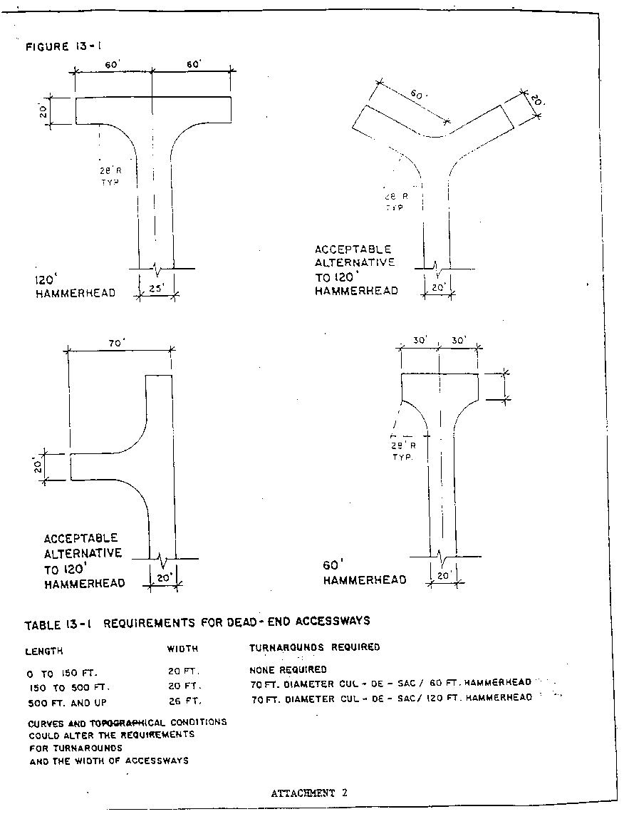

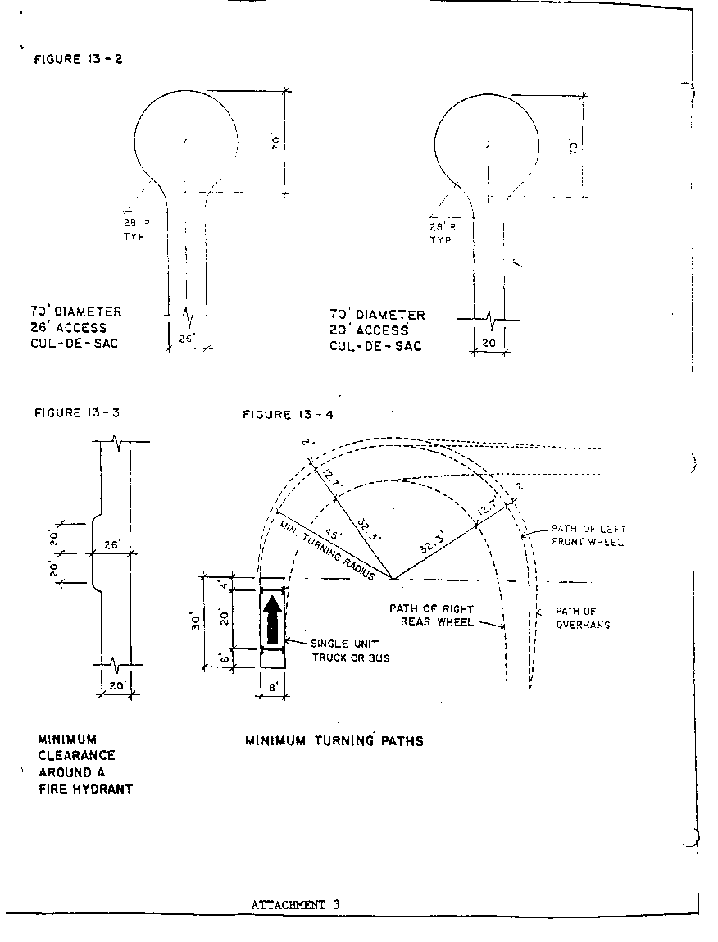

(Ord. 00-9-12-13, 9-12-2000, eff. 10-9-2000)